HANDOUT ON ECONOMICS

AGYAPOMAA GYEKE – DAKO (PhD)

&
DAVID TANOH ADUHENE

2016

AKNOWLEDGEMENT
I am grateful to the Almighty God for granting me the grace to successfully put this handout together. My deepest gratitude also goes to Mr. Solomon Aboagye for his immense support.

COURSE OBJECTIVES
The focus of this course is to introduce readers to the basic principles of economics and to provide the fundamental tools used in economic analysis. Specifically, the course seeks to:

- Equip readers to appreciate and understand the forces that impact on their daily operations. This helps in effective decision making.
- Establish how prices are determined in a market
- Explain why and how consumers choose to buy a particular commodity.
- Understand the main reasons why firms produce which is profit maximisation and determine how a firm decides on its price and output that will make it maximise profit.
- Understand macroeconomic variables

TABLE OF CONTENTS
AKNOWLEDGEMENT 1
COURSE OBJECTIVES 2

CHAPTER ONE 5
THE NATURE AND SCOPE OF ECONOMICS 5
1.1 Nature of Economics 5
1.2 Scarcity, Choice, Scale of Preference and Opportunity Cost concepts 7
1.3 Economic System 8
1.4 The Production Possibility Frontier (PPF) 11
1.5 Branches of Economics 13
ASSIGNMENT 13

CHAPTER TWO 14
DEMAND AND SUPPLY ANALYSES 14
2.1 DEMAND ANALYSIS 14
2.1.1 Definition and the law of demand 14
2.1.2 Some Factors influencing Demand of a commodity 15
2.1.3 Individual and Market Demand 17
2.1.4 Change in Quantity Demanded versus Change in Demand 18
2.2 SUPPLY ANALYSIS 19
2.2.1 Definition and the law of Supply 19
2.2.2 Some factors influencing Supply 20
2.2.3 Individual and Market Supply 21
2.2.4 Change in Quantity Supplied versus Change in Supply 22
2.3 Equilibrium Analysis 23
2.4 Price Controls 25
2.4.1 Minimum Price Control (Price Floors) 25
2.4.2 Maximum Price Control (Price Ceiling) 26

CHAPTER THREE 27
ELASTICITY OF DEMAND AND SUPPLY 27
3.0 What is Elasticity of Demand 27
3.1 Own Price Elasticity of Demand 28
3.1.1 Interpretations of own price elasticity of demand 28
3.1.2 Determinants of Price Elasticity of Demand 29
3.2 Cross-Price Elasticity of Demand 29
3.2.1 Interpretations of cross price elasticity of demand 29
3.3 Income Elasticity of Demand 29
3.3.1 Interpretations and policy implications of income elasticity of demand 30
2.4 Price Elasticity of Supply 30
3.4.1 Interpretations of own price elasticity of supply (Pes) 30
ASSIGNMENT 32

CHAPTER FOUR 36
THEORY OF CONSUMER BEHAVIOUR 36
4.1 Who is a Consumer? 36
4.2 Assumptions 36
4.3 Definitions of Key Concepts 36
4.4 Equilibrium of the Consumer or Utility Maximization 38
4.5 Disequilibrium of the Consumer and how it is restored 38
4.6 Paradox of Value 39
ASSIGNMENT 40

CHAPTER FIVE 41
THEORY OF PRODUCTION 41
5.0 Production 41
5.1 Definition of Key Concepts 41
5.2 Short-Run Production Analysis 42
5.2.1 The Stages of Production 42
5.3 Key Relationship Between TP, AP and MP 43

CHAPTER SIX 44
THEORY OF COST 44
6.0 Defining Cost 44
6.1 Short-Run Analysis of Cost 44
6.2 Key Relationship between AVC, AC and MC 46
Fig. 12: Relationship between AVC, AC and MC 46
ASSIGNMENT 47
ANSWER TIPS 49

CHAPTER SEVEN 51
MARKET STRUCTURES 51
7.1 Introduction 51
7.1.1 Price Takers 51
7.1.2 Price Makers. 51
7.2 Definition of Some Key Concepts 52
7.3 Types of Market Structures 53
7.3.1 PERFECT COMPETITION 53
7.3.2 MONOPOLY 56

CHAPTER EIGHT 59
MAJOR MACROECONOMIC VARIABLES 59
8.0 Introduction 59
8.1 ECONOMIC GROWTH 59
8.1.1 What is Economic growth? 59
8.1.2 Economic growth and business cycle 59
8.1.3 Sources or Causes of Economic growth 61
8.1.4 Benefits of economic growth 62
8.1.5 Potential costs of economic growth 62
8.2 INFLATION 63
8.2.1 Defining Inflation 63
8.2.2 Types of Inflation 63
8.2.3 Causes of Inflation 64
8.2.4 Effects of Inflation 65
8.2.5 Controlling or Reducing Inflation 66
8.3 UNEMPLOYMENT 68
8.3.1 Defining Unemployment 68
8.3.2 Types of unemployment 68
8.3.3 Costs of unemployment 69
Concluding notes 70

CHAPTER NINE 71
NATIONAL INCOME AND GDP ACCOUNTING 71
9.0 Introduction 71
9.1 Definition of Key Concepts 71
9.2 Approaches/Methods of Measuring National Income 72
Circular Flow of Income 72
9.3 Expenditure Approach 74
9.4 Income Approach 75
9.5 Uses of National Income Statistics 75
9.6 Limitations of using National Income as a measure of welfare across countries 76
ASSIGNMENT 78
ANSWER TIPS 80

CHAPTER ONE

THE NATURE AND SCOPE OF ECONOMICS

1.1 Nature of Economics
We cannot have everything that we want. This is because our wants are many but the resources that we need to satisfy those wants are limited. Even the richest person in the world still cannot get everything he wants. With all the wealth of this rich person, he may want to go on holiday and at the same time work. Yet, he may not be able to do both because of time. The fact that our wants are many but the resources needed to achieve these wants are limited depicts the concept of scarcity. Thus, taking decisions regarding the efficient use of resources is primary and very apt especially when one considers the scarce nature of these resources. What then are resources? Resources are simply things used to produce a good or service or, things used to achieve a goal. In Economics, we distinguish between four broad categories of resources (usually referred to as factors of production); namely Land, Labour, Capital and Entrepreneurship.

- Land
In economics, land comprises all naturally occurring resources whose supply is inherently fixed. Examples are any and all particular geographical locations, mineral deposits, forests, fish stocks, atmospheric quality etc.

- Capital
In economics, capital is described as an already-produced durable good or any non-financial asset that is used in the production of goods or services. Capital consists of anything that can enhance a person's power to perform economically useful work—a stone or an arrow is capital for a caveman who can use it as a hunting instrument, and roads are capital for inhabitants of a city. Homes and personal autos are not usually defined as capital but as durable goods because they are not used in the production of saleable goods and services. Capital is distinct from land (or non-renewable resources) in that capital can be increased by human labour. At any given moment in time, total physical capital may be referred to as the capital stock (which is not to be confused with the capital stock of a business entity).

- Labour
Labour refers to the aggregate of all human physical and mental effort used in the creation of goods and services. Sometimes labour is manual (unskilled labour) but at other times labour is trained (skilled labour).

- Entrepreneur
An entrepreneur is an individual who, rather than working as an employee, runs a small business and assumes all the risks and rewards of this business venture, idea, or good or service offered for sale.

A crucial thing to know is that these resources, be it land, capital, labour and entrepreneur are scarce but have alternative uses. This means that pursuing a goal with any of these resources requires making a choice. Once a choice is made, we would have given up its other alternative use(s). For instance, a hospital may want to use its revenues to increase the number of hospital beds. Meanwhile, these funds could have been channeled into other projects e.g. building new surgery theatres, employing more doctors/nurses, increasing salaries of its workers, buying more X-ray machines etc. These are the alternative uses of scarce resources as was mentioned in the previous sentence. Now, if the hospital chooses to spend these revenues on the beds, it would have sacrificed projects such as building new surgery theatres, employing more doctors/nurses, increasing salaries of its workers, buying more X-ray machines etc. These forgone projects which could have been pursued using the same funds by the hospital is said to be the Opportunity cost of buying the beds by the hospital. In the next section, scarcity, choice and opportunity cost are discussed.

1.2 Scarcity, Choice, Scale of Preference and Opportunity Cost concepts
Scarcity: The term scarcity refers to the limited availability of resources relative to the unlimited needs of mankind or society. It is established that each of the factors of production (namely land, labour, capital and entrepreneur) do not only have alternative uses but more crucially, are available only in limited quantities. Meanwhile households, firms and even governments have unlimited wants to achieve. As a result of the scarce nature of economic resources, there is always a need for economic agents (i.e. households, firms and government) to make choices and make good use of resources. Thus, economists argue that the central problem in economics is scarcity of resources without which there will be no need to study economics.

Scale of Preference: Economic agents are expected to devise an accurate and efficient mechanism to make sure that scarce resources are not wasted but rather used as efficiently as possible. In that regard, it is important that the unlimited wants are always prioritized so that the economic agents in question are able to channel their resources to achieve them. Consequently, in making choices, economic agents have to start with the ones they value most. The arrangement of wants in order of preference or priority is referred to as Scale of preference. A scale of preference simply shows a list of wants in order of importance or priority. This would then allow economic agents to make effective choices among alternative needs.
To understand this clearly, consider a situation in which God has appeared to you and asked for a list of your five most pressing wants. You are going to be giving out this list according to how much you value your wants. So say, if in your mind you value a car most, the car is going to be priority and therefore top on your list. If the next thing you value is a laptop, then the laptop goes next on your list. If the third thing you value is a cell phone, that goes third on your list etc.

Choice: Choice becomes necessary because of the problem of scarcity. Choice is simply the act of selecting among alternatives. A choice is made by following the practice that “until the topmost project or preference is achieved funds would not be used to achieve a less important project”.

Opportunity cost: When a choice is made, you would observe that your choice of a particular goal requires you to sacrifice some other goals. The value of the next best alternative foregone is referred to as Opportunity cost. Thus, opportunity cost is the value of the forgone alternative. It is important to note that these concepts are very relevant in the decisions of consumers, firms and governments. Referring to the example on the scale of preference, if the resource of the individual can just get the car, the next best alternative is the laptop which means that the value of the laptop becomes the opportunity cost of getting the car.

Economics as a Social Science
Economics is considered a science because it uses scientific tools in its analyses. Natural Scientists observe, set hypotheses, test the hypothesis and draw conclusions. Economists do same. The only difference between economists and natural scientists is that economists deal with human behaviour. This is why we say economics is a social science.

Definition of Economics
Combining all the ideas above, we can have a suitable definition for economics. Some of the differences may reflect changing views of the subject itself or different views among economists. Robins (1932) developed implications of what has been termed perhaps the most commonly accepted current definition of the subject. Lionel Robbins defined Economics as a science which studies human behaviour as a relationship between ends and scarce means which have alternative uses.
Thus, it is almost an overall consensus among modern economists that, the subject economics relates to the scientific study of how society chooses to allocate scarce resources which have alternative uses to meet the unlimited wants of society now and/or in future.
Economics is a very broad discipline in the sense that it describes methods useful for directing every resource; from the resources of a household to maximize household welfare to the resources of a firm to maximize profits and to that of the state.

1.3 Economic System
To solve the basic or central economic problem which is scarcity, there is always the need to provide answers to the questions of what to produce, how to produce, and for whom to produce.

What to produce?
Societies have to decide the best combination of goods and services to produce to meet their needs. For example, how many resources should be allocated to consumer goods, and how many resources to capital goods, or how many resources should go to schools, and how many to road construction, and so on. If resources were not scarce, we would not be .thinking about this

How to produce?
Societies also have to decide the best combination of inputs to use to produce the desired output of goods and services. For example, how much land, labour, and capital should be used to produce consumer goods such as computers and motor cars. If resources were not scarce, we could produce with any amount of resources we wanted to use.

For whom to produce?
Finally, all societies need to decide who will get the output from the country’s economic activity, and how much they will get. For example, who will get the computers and cars that have been produced? Are our targets the rich or the poor? This is often called the problem of distribution.

Clearly, to provide sound solutions to these three basic societal problems, there must exist a workable structure or system to ensure an efficient or satisfactory way out. The system which determines how to allocate society’s resources is referred to as an economic system. An economic system is a system of production, resource allocation, and distribution of goods and services in a society or a given geographic area. There are broadly three types of economic system.

A Centrally Planned Economy (also called Socialist Economy) is an economic system in which the state or government makes economic decisions rather than the interaction between consumers and businesses. Countries which are close to being centrally planned economy include Cuba, Russia etc.
Characteristics of a Centrally Planned Economy
- The government controls all aspects of the economic production. In other words, the government decides what goods will be produced and how they will be produced.
- The government decides how resources are distributed and used. For example, if the government thinks we need more goods in a particular area, they will make that decision, not the businesses in that area.
- The government needs to make the decisions. It is assumed that the needs of the people are not met in a market economy; therefore, in a centrally planned economy, the government controls decision-making.
- The government can determine the price of goods and services.

A Market (Free) Economy (also called Capitalist Economy) is an economy in which decisions regarding investment, production, and distribution are based on market -determined supply and demand, and prices of goods and services are determined in a free price system. Countries which are close to being a market economy include U.S.A, Japan, etc.

Characteristics of a Market Economy
- A market economy is a type of economic system where supply and demand regulate the economy, rather than government intervention.
- A true free market economy is an economy in which all resources are owned by individuals.
- The decisions about the allocation of those resources are made by individuals without government intervention. There are no completely "free-enterprise" or market economies.
- In a market economy, almost everything is owned by individuals and private businesses- not by the government. Natural and capital resources like equipment and buildings are not government-owned.
- The goods and services produced in the economy are privately- owned.

Differences between planned economy and market economy
- A pure planned economy has one person or group who controls what is produced; all businesses work together to produce goods and services that are planned and distributed by the government.
- Planned economies have several advantages. Ideally, there is no unemployment, and needs never go unfulfilled; because the government knows how much food, medicine, and other goods are needed, it can produce enough for all.
- A pure market economy is one perfectly free of external control. Individuals are left up to themselves to decide what to produce, who to work for, and how to get the things they need.
- Because there is no regulation ensuring equality and fairness, market economies are burdened with unemployment, and even those with jobs can never be certain that they will make enough to provide for all of their needs.
- Because they do not need to wait for word from the government before changing their output, companies under market economies can quickly keep up with fluctuations in the economy, tending to be more efficient than regulated or planned markets.

Mixed Economic system
In reality, countries hardly reflect a pure planned economic system or a pure market economic system. We usually find a blend of the two economic systems although economies will generally be skewed towards one side. This blend is called a mixed economic system. The Mixed Economic System is an economic system in which both the private enterprise and a degree of state monopoly (usually in public services, defense, infrastructure, and basic industries) coexist. All modern economies are mixed where the means of production are shared between the private and public sectors. The mixed economic system is also called dual economy.
Since a mixed economy includes a mix of both private and government control, its characteristics are both that of capitalism and socialism. The balance between the two ideals can vary greatly between countries, sometimes leading to a lack of consensus on whether the economy is capitalist, socialist or mixed.

1.4 The Production Possibility Frontier (PPF)
There are several economics concepts which can be used to illustrate the concept of scarcity, opportunity cost and efficiency. One of such concepts is the Production Possibility Frontier (PPF), sometimes called production–possibility curve, production-possibility boundary or product transformation curve. The PPF is essentially a curve which shows various combinations of goods and services that an economy can produce using its scarce resources, usually fixed amount of each resource (called factors of production which includes labour, capital, land and entrepreneur) with a given level of technology. Thus, the frontier depicts the maximum (i.e. possible) output that an economy can produce using its resources and given level of technology. A PPF is normally drawn as concave to the origin of the graph as shown in Fig. 1

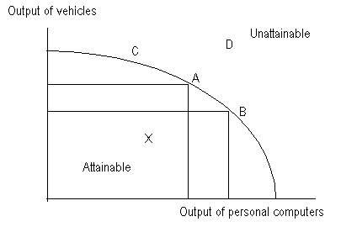
Fig. 1: Production–possibility frontier

Illustrating Opportunity Cost
The reason for the concave curvature of the PPF to the origin is explained by the fact that the output of one good must fall if the country desires to increase the output of the other good. For instance, in Fig. 1, the country ought to reduce the production of vehicles in order to increase the production of personal computers given by the movement from point A to B. Thus the PPF actually shows the production tradeoffs between the goods an economy produces given fixed resources. If resources were not scarce, countries could produce as many computers they want without sacrificing any amount of vehicles. This tradeoff is what is referred to as Opportunity cost. Recall that opportunity cost has earlier been defined as the alternative project(s) forgone which could have been done. Hence, the movement from point A to B is the opportunity cost of producing more personal computers, which is how many vehicles you have to sacrifice. For non-linear PPF like the one shown in Fig. 1, the quantity of vehicles that ought to be sacrificed to produce more computers increases as you move down the PPF. In other words, the rate at which the country substitute computers for vehicles, referred to as the Marginal Rate of Transformation (MRT) increases along the PPF. Since the PPF shows the maximum (i.e. possible) output that an economy produces using its resources and given level of technology, then the maximum output can increase when there is an increase in resources and the converse is also true. When this happens, it is not only the maximum output which increases, but also the PPF also shifts outwardly and the reverse also holds. Note that the factors that increase output are the same factors which shift the PPF outwardly and the vice versa (see Table 1).

Table 1: Factors responsible for a shift of the PPF
Factors that increases output and shift the PPF outwardly | Factors that reduces output and shift the PPF inwardly
1. Improvement in labour skills and health | 1. Unemployment and underemployment of labour
2. Increase in resource availability | 2. Natural disasters such as earthquake, flood etc.
3. Discovery of new resources e.g. oil discovery in Ghana | 3. Shortage of critical resources
4. Population growth | 4. Employment of obsolete technology
5. Advancement or improved technical efficiency

Efficiency
Usually, in interpreting the various points on the PPF, three key regions are analyzed i.e. points located on the PPF, points located inside the PPF and points located outside the PPF
Points located on the PPF: It is earlier established that along the PPF, a country substitutes one commodity/good for the other which is the tradeoff between the two goods illustrating the concept of opportunity cost. Since the PPF depicts the maximum output that an economy produces, then along the PPF, the different combinations of the two goods are all considered efficient resource allocation. This implies that all points on the PPF are points of efficiency, though representing different combination of the goods and service produced by the country. Referring to Fig. 1 above, points such as A and B are all points of efficiency.
Points located within (inside) the PPF: Points such as X which lie inside the PPF are considered inefficient resource allocation. Remember that the PPF defines an economy’s maximum production frontier/boundary. In other words, if an economy operates within the PPF, it implies that economy is not using its resources efficiently.
Points located outside (beyond) the PPF: Points such as D and C which lie above the PPF cannot be attained. Remember that the PPF defines the country’s maximum production frontier/boundary. The factors outlined in Table 1 above which increase output and consequently shift the PPF outwardly are the same factors which can enable a country to move to the unattainable points such as D and E.

1.5 Branches of Economics

There are two main branches of economics; microeconomics and macroeconomics

Microeconomics
Microeconomics is that part of economics that deals with decision-making by individuals and businesses. This means also taking into account taxes and regulations created by governments. Microeconomics focuses on the role producers and consumers play in an economy and the forces that determine the price levels seen in the economy. For example, microeconomics can look at why a consumer makes a decision to buy a certain good or why a producer charges a certain price for its product.
Macroeconomics
Macroeconomics, on the other hand, is the field of economics that studies the behaviour of the economy as a whole and not just on specific companies or individuals. So for instance, issues like unemployment, inflation and exchange rate are all addressed under macroeconomics because they concern the entire economy.

ASSIGNMENT
Question One
Discuss five merits and demerits of each of the three economic systems

CHAPTER TWO

DEMAND AND SUPPLY ANALYSES

2.1 DEMAND ANALYSIS

2.1.1 Definition and the law of demand
Suppose we could ask consumers of how many bars of chocolate they are able to buy at different prices, then we are analysing their demand for chocolate. In Economics, demand is the quantities of goods and services that individuals are willing to and have the ability to buy at various prices over a period of time. There are important phrases in this definition that need to be highlighted. The first is ‘quantities of goods and services’. This obviously suggests that demand does not refer to a specific quantity but rather various quantities. The second is that if an individual is willing to buy a certain good but is not able to buy that good it does not qualify to be demand. Third, the various quantities should be bought at different prices. This means that demand refers to an entire relationship and not a specific point. The analysis of the theory of demand is at the centre of economics.

2.1.2 Some Factors influencing Demand of a commodity
Think about what will influence you to buy a good? In thinking about these factors, ensure that you are thinking about them in isolation.

- Price of the commodity in question
It is clear from the definition of demand provided that price is not just a major factor that will influence you to buy a certain good but perhaps the most important factor. You would be less willing and able to buy a good if the price was high and vice versa, would you not? Hence, generally, at higher prices, individuals are less willing and less able to buy goods and services and thus, demand for goods and services is normally assumed and expected to be less at higher prices and the vice versa, holding all other factors constant. This is referred to as the law of demand. The law of demand in its simple terms states that more goods and services are demanded at lower prices and less demanded at higher prices, all other things constant. This law implies that the price of a commodity in question and the demand for it tend to move in different directions so that when the price of goods or services is increasing, the quantity demanded would be decreasing and the vice versa. In other words, there is a negative or an inverse relationship between own price and quantity demanded. In fact, it is because of this law that the demand slopes negatively or inversely or downwards from left to right as shown in Fig. 1.
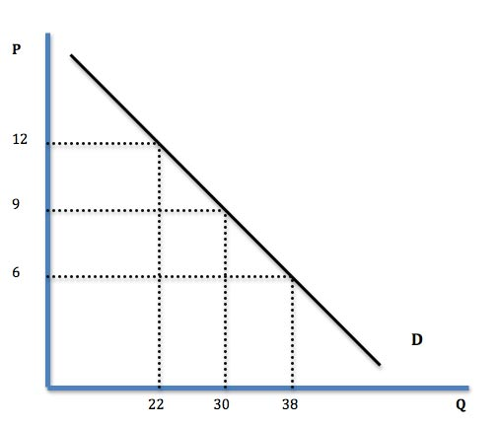
Fig. 1: demand curve

Now, why would you buy more if the price is low and less if the price is high? You would do so because, one, supposing we had two goods, A and B which were substitutes and good A was the good in question, an increase in the price of good A, would make consumers switch to good B. This is what we call the Substitution Effect. Let us still assume that the price of good A has increase. With same amount of income, we will be able to buy fewer goods, this is called Income Effect.

- Prices of related commodities
In real life, people consume more than one commodity. These various commodities that we consume are invariably related to other goods either as substitutes or complements. Your purchase of a commodity is also dependent upon the prices of these other related commodities (i.e. being either substitutes or complements).
Substitutes: Substitutes are goods that serve the same purpose. This implies that demanding one would lead to the neglect or non-purchases of the other good. Suppose the price of a substitute good increases, the consumer would buy more of the commodity in question and demand less of the substitute and the vice versa. Note that this is different from the substitution effect described earlier on. Under the substitution effect, while we look at things from the perspective of the good in question, with this particular one, we are considering the price of a substitute good and how it influences the demand for the good in question. Examples of substitutes include Milo and Bournvita. If Milo is our good in question, we would like to know how an increase in the price of Bournvita will influence the demand for Milo.

Complements: Two goods are said to be complements in demand if buying one would lead to the purchases of the other good. This happens because two goods must be consumed together or jointly to achieve a certain level of satisfaction e.g. car and fuel. However unlike substitutes, for complementary goods, more of a commodity in question is purchased if the price of its complement falls, and the vice versa.

- Income levels of consumers
Remember that for demand, consumers should not just be willing to buy the product but should also be able to buy the product. This means that consumer’s income is one of the basic factors influencing the demand of a product. How are you able to buy the product? Generally, you are able to buy more of a good when you have more income. This implies that when the income of consumers increases, they are likely to buy more of the good and the vice versa “other things being equal”. These goods whose demand will have a positive relationship with income are called Normal goods. Yet, there are certain goods whose demand will increase when income decreases and vice versa. These are called inferior goods. Thus, for inferior goods, there is a negative relationship between income and demand.

- Taste and preferences
A consumer’s taste and preference is very important when it comes to demanding for a particular good. Demand is high if a consumer’s taste and preference for a commodity is high and the vice versa “other things being equal”. This possibly explains why there is low demand for meat among vegetarians. Taste and preferences also capture fashion, occasions, religious beliefs and even cultural practices. For instance, there are some occasions and fashions which require the use of certain goods. These form part of the tastes and preferences of consumers. When the occasion or fashion is over those goods are not demanded any longer.

- Consumer Expectations of future price changes
Changes in consumer expectations can also change the demand for a product. For example, if consumers suddenly expect the price of automobiles to significantly increase next year, the demand for automobiles today will increase “other things being equal”. If consumers expect future prices to be higher, they will substitute current purchases for future purchases. This type of consumer behaviour often is referred to as stockpiling and generally occurs when products are durable in nature. The current demand for a perishable product such as bananas generally is not affected by expectations of higher future prices.

- Population
The demand for a product is also influenced by changes in the size and composition of the population. Generally, as the population rises, demand also increases “other things being equal”. Over the twentieth century, the demand curve for food products increased substantially following considerable rise in population. Thus, “all other things being equal”, larger households have a relatively higher demand than smaller households. Also, it is important to note that changes in the composition of the population can also affect the demand for a product. To the extent that middle-aged consumers desire different types of products than retirees, an increase in the number of a country’s population in the 30- to 40-year-old age bracket will increase the demand for products like real estate, automobiles and the likes. Similarly, as a greater proportion of the population ages, the demand for medical services will tend to increase.

2.1.3 Individual and Market Demand
Individual Demand
The individual demand is the demand of one individual or firm. It represents the quantities of a particular commodity that a single consumer would buy different prices at a specific point in time. While the term is somewhat vague, individual demand can be represented by the point of view of one person, a single family, or a single household.

Market Demand
Market demand provides the total quantities demanded by all consumers for a particular commodity. In other words, it represents the aggregate of all individual demand.
Market demand is an important economic marker because it reflects the competitiveness of a marketplace, a consumer’s willingness to buy certain products and the ability of a company to leverage itself in a competitive landscape. If market demand is low, it signals to a company that they should terminate a product or service, or restructure it so that it is more appealing to consumers. Market demand is what we will be interested in as in the real world we hardly will find just one individual buying a product.

Example
Let us assume there are only three consumers in a market of a product. The following table shows their individual demand schedules as well as the market demand which is obtained by horizontally adding the quantities demanded by individuals at a given price.

Unit Price | Individual demand |  |  | Market demand
Unit Price | Aboagye | Agyapomaa | Turkson | Market demand
8 | 0 | 0 | 44 | 44
7 | 0 | 16 | 51 | 67
6 | 4 | 32 | 57 | 93
5 | 8 | 51 | 65 | 124
4 | 13 | 75 | 74 | 162
3 | 20 | 104 | 86 | 210
2 | 30 | 147 | 103 | 280
1 | 46 | 220 | 134 | 400

It is observed that at any given price different quantities are bought by Aboagye, Agyapomaa and Turkson. That is the individual demand of each of the consumers. The last column shows the market demand which is a horizontal summation of the demand by the three consumers.

2.1.4 Change in Quantity Demanded versus Change in Demand
Change in quantity demanded is a change in demand (increase or decrease) that arises from changes in the own price of the good. This always results in a movement along the same demand curve. For instance, a change in the price from P₁ to P₂ results reduces quantity demanded from Q₁ to Q₂ in the diagram (Fig. 2) below: We move along the same demand curve.
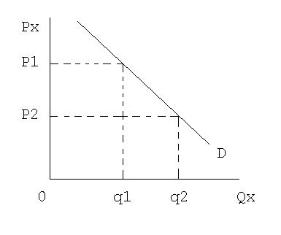
Fig. 2: Change in quantity demanded
On the other hand, we have seen that some other factors influence demand apart from the price of the product itself. We are however unable to show on a demand curve how changes in these other factors influence demand since the demand curve shows a relationship between price and quantity. When a factor like taste and preference improves, it results in an increase in demand when price has not changed. Thus, at the same price, we can show an improvement in taste and preferences by shifting bodily the demand curve to the right. This means that other determinants of demand which includes changes in income levels, changes in taste and preferences and changes in population are responsible for the bodily shift of the demand curve (i.e. change in demand). This is what economists refer to as a change in demand. When the demand curve shifts to the right it suggests an increase in demand which means that any factor that increases demand will cause this. However, a shift of the demand curve to the left implies a decrease in demand which is caused by factors that decrease demand. Fig. 3 below depicts a change in demand.
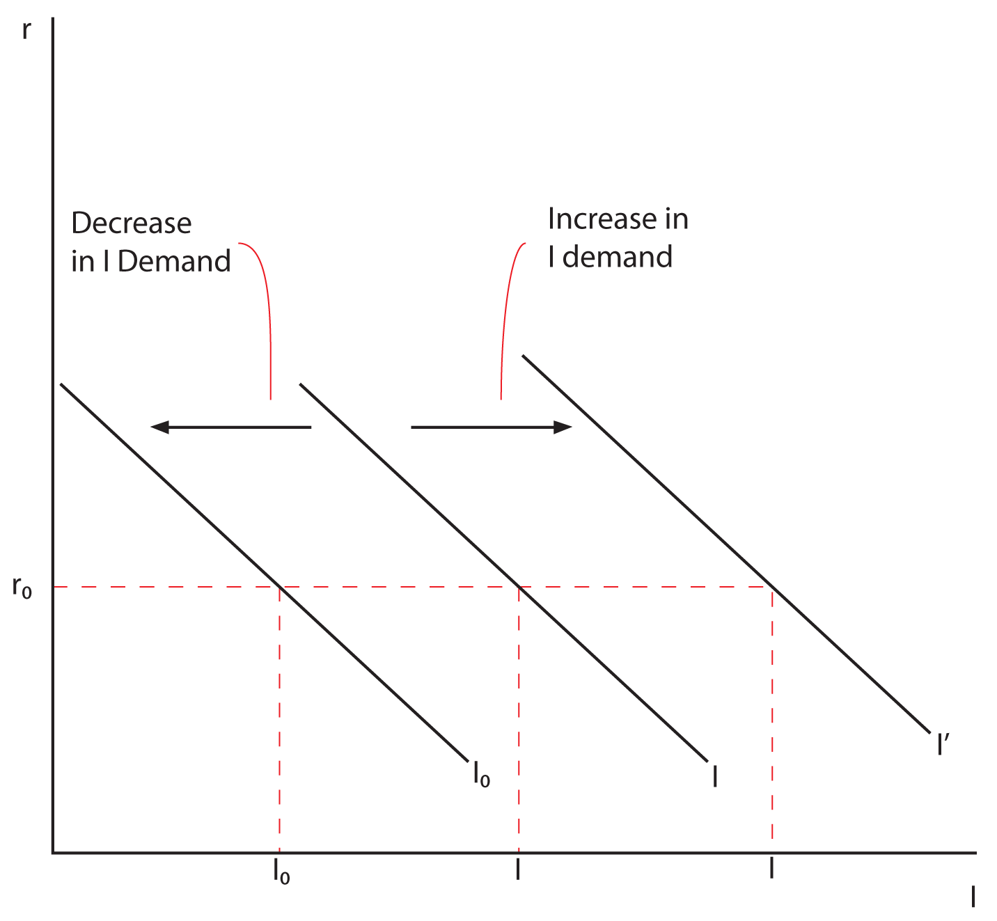
Fig. 3: Change in demand

2.2 SUPPLY ANALYSIS

2.2.1 Definition and the law of Supply
After studying the behaviour of consumers on the market, we are now interested in studying the behaviour of producers on the market. The study of the behaviour of producers or suppliers on the market is done under the topic supply. Supply is an economic concept that refers to the total amount of a specific good or service that its sellers/producers are willing and able to offer for sale or at different prices at a given period of time. Supply also relates to the amount of good or service available to consumers at a specific price.
Generally, producers/sellers are more willing and able to offer goods or services for sale at higher prices and thus, supply is more at higher prices and vice versa. This is referred to as the law of Supply which states that more is supplied at higher prices and less supplied at lower prices “other things being equal”. This law implies that own price and quantity supplied tend to move in the same direction so that when the price of the commodity in question is increasing quantity supplied would also be increasing and vice versa. In other words, there is a positive or a direct relationship between own price and quantity supplied. Graphically, the supply curve slopes positively or upwards from left to right when drawn against own price as shown in Fig. 5

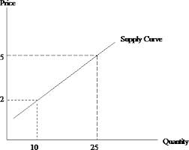
Fig. 5: Supply curve

2.2.2 Some factors influencing Supply
- Price of the commodity in question
The preceding discussion clearly shows that price is a major factor that influences how much producers are willing and able to put on the market for sale.
When price of the commodity in question (i.e. the own price) is high, the producer or seller is more willing and able to supply more “other things being equal”. They do this so as to make more revenue at the higher price. The reverse is also true.
- Prices of related commodities
Substitutes (Two goods are said to be substitutes in supply if producing one would lead to the neglect or non-production of the other good or if they compete for the use of the same resource.). When the price of a substitute good increases, the producer would supply less of the commodity in question and supply more of the substitute so that he makes more revenue from the substitute “other things being equal” and the vice versa. Eg wheat and rice are substitutes under supply because they both use land in their production
Complements (Two goods are said to be complements in supply if producing one good simultaneously leads to the production of the other good). If the other commodity is a complement to another product, then the producer, would supply more of the product as the price of the complement increases and vice versa “other things being equal”.
- Input prices
Inputs are products which are used in the production of other products. When the prices of inputs rise, it is an indication of a rise in cost of production and this tends to reduce production and hence supply “other things being equal”. The converse is also true. For instance milk is an input for ice cream. If the price of milk increases, the cost of producing ice cream will go up and this will reduce the supply of ice cream.
- Government business policies
When government business policies such as taxation and subsidy are favourable to the producer, more is supplied “other things being equal” and the vice versa.

- Technology
As a firm advances in technology, the efficiency of production is enhanced and this allows the producer to produce more in a relatively shorter time period and even at a relatively lower cost. Thus, technological advancement tends to increase production and hence supply “other things being equal”. However, this conclusion is not always true since some level of technology can drive away some producers out of business. Example, the introduction of computers has led to a decline in the production and supply of typewriters.
- Number of Firms
The number of firms in an industry affects the position of the supply curve. As additional firms enter an industry, more and more output is available at each given price “other things being equal”. Similarly, as firms leave an industry, fewer units are sold at each price, and the supply decreases (shifts to the left).
- Producer Expectations
Like consumers, producer expectations about future prices also affect the supply of a commodity. In effect, selling a unit of output today and selling a unit of output tomorrow are substitutes in production. If firms suddenly expect prices to be higher in the future and the product is not perishable, producers can hold back output today and sell it later at a higher price “other things being equal”. This has the effect of shifting the current supply curve to the left.

2.2.3 Individual and Market Supply
Individual Supply
The individual supply is the supply of one seller or producer. It represents the quantities of a particular commodity that a single seller would sell at various prices at a specific point in time.

Market Supply
Market supply provides the total quantity supplied by all sellers or producers of a particular commodity. In other words, it represents the aggregate of all individual supply.

Example
Let us assume there are only three producers in a hypothetical market of a product. The following table shows their individual supply schedules as well as the market supply which is obtained by horizontally adding the quantities supplied by individuals at a given price.

Unit Price | Individual supply |  |  | Market supply
Unit Price | ABC Limited | Fan Gant  Company | Excel Marketing | Market supply
800 | 120 | 220 | 440 | 780
700 | 100 | 160 | 351 | 611
600 | 70 | 132 | 257 | 459
500 | 65 | 121 | 165 | 351
400 | 55 | 115 | 102 | 272
300 | 40 | 104 | 86 | 230
200 | 30 | 101 | 70 | 201
100 | 25 | 90 | 66 | 181

It is observed that at any given price each firm /producer has its unique supply of the product. That is the individual supply of each of the firms. The last column shows the market supply which is a horizontal summation of the supply by the three producers.

2.2.4 Change in Quantity Supplied versus Change in Supply
Similar to that of demand, change in quantity supplied (increase or decrease) solely arises from changes in the own price of the product. This always results in a movement along the same supply curve as shown in the diagram (see Fig. 6) below:
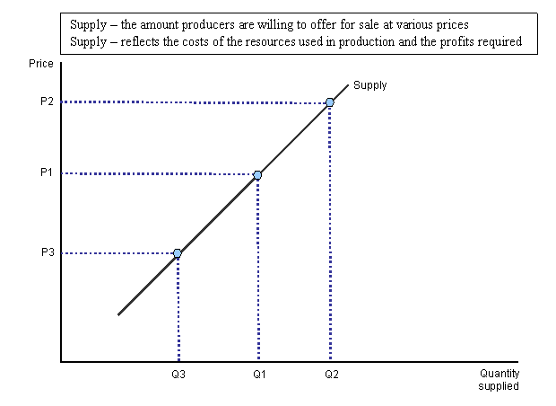 Fig. 6: Change in quantity Supplied

A change in supply on the other hand is a bodily shift of the supply curve either to the left (which implies decrease in supply) or to the right (which implies increase in supply) with price remaining at the same level. This implies that a change in supply results from changes in all the other determinants of supply other than the own price (i.e. the supply shifters) of the product. A shift of the supply curve to the right implies an increase in supply and it is caused by any factor apart from the price of the product which is capable of increasing supply. For instance, a fall in the price of inputs. However, a leftward shift of the supply curve implies a decrease in supply and it is caused for instance by expected increase in future prices. Fig. 7 below represents a change in supply.

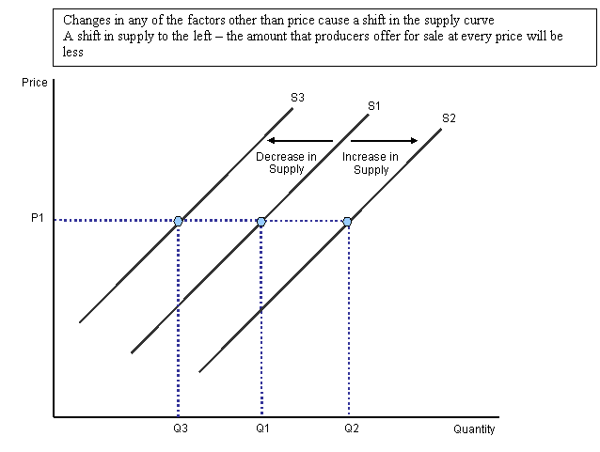 Fig. 7: Change in Supply

2.3 Equilibrium Analysis
In the previous two sessions, we analysed the behaviour of consumers and producers separately. However, in the real market, consumers and producers in the market interact. None of them operates in isolation. In their interaction, there may be a single price for which how much consumers are willing and able to buy is just equal to how much producers are willing and able to put on the market for sale. That price is called the equilibrium price and its associated quantity is the equilibrium quantity. Hence, market equilibrium is a market state where the quantity supplied on the market is equal to the quantity demand in the market. This implies that at equilibrium the quantity demanded is the same as quantity supplied and thus, there is no surplus or shortage when a market is in equilibrium. The equilibrium price is the price of a good or service when the supply of it is equal to the demand for it in the market. When a market is in equilibrium, there is no tendency for both suppliers and demanders to change their decisions regarding price and quantity. The equilibrium analysis could be done either graphically or mathematically. In the section that follows, we discuss how we can employ graphs and algebra to examine market equilibrium and how equilibrium price and quantity change (i.e. distort or restore) in the face of policies and events. If prices and quantities are not allowed to change when we are in equilibrium, how then do we find prices in the real world changing? Prices in the real world change when any factor influencing demand or supply or both changes apart from the price of the product itself.

Graphical Approach
There are about four (4) broad steps to be followed when asked to use appropriate diagrams to analyse market equilibrium situations and how equilibrium prices and quantities change.
- Foremost, assume that the market was originally in equilibrium before the policy was implemented or the event took place.
- Then, identify the immediate impact point (i.e. who is immediately affected? producers or consumers?) of the policy or event.
- Is the policy or event leading to an increase or decrease in demand or supply. In most cases, the policy may affect only one of them i.e. either the producers or consumers. Yet, in some situations, both producers and consumers are affected in the same direction by the event or policy while in other situation, in the opposite direction.
- If it results in an increase in demand, shift demand curve to right and the vice versa. Similarly, if it results in an increase in supply, shift supply curve to right and the vice versa.

Mathematical or Algebraic Approach
Here, since it is a mathematical approach, you would not make use of the demand and supply curves for the market equilibrium analysis. Rather, you would be given the demand and supply functions.
Generally, the demand and supply functions are given respectively as:
Qd = a – bP and Qs = c + dP

Where;
P is the price of the commodity
a is the intercept of the demand function or curve
b is the slope of the demand function or curve and it is negative, emphasizing the negative relationship between own price and quantity demanded
c is the intercept of the supply function or curve
d is the slope of the supply function or curve and it is positive, emphasizing the positive relationship between own price and supply.
Qd is the quantity demanded
Qs is the quantity supplied

The demand and supply functions specified above are called normal demand and supply functions. When price (P) becomes the subject of either demand or supply function, we obtain the inverse demand or supply functions. For instance, the inverse demand and supply functions can be specified as follows:
P = a – bQ and P = c + dQ

Now, to determine the market equilibrium price and quantity, the following steps are important:
- In equilibrium, Qd = Qs
When you do this, you would obtain the equilibrium price and quantity before the implementation of any policy or the occurrence of any event (See worked example on pages 30 and 31).

2.4 Price Controls
Sometimes, consumers feel the equilibrium price is too high for them. When this happens, they run to the government to ask for the price to be reduced. When the government agrees to safeguard the interest of consumers, it sets a ceiling beyond which the prices cannot go. This is called a price ceiling or a maximum price. The producer sometimes feels that the equilibrium price is too low for him. When this happens, they can run to the government to ask him to set a price above the equilibrium price. When this happens, the government may agree to set what we call a minimum price or a price floor to protect the interest of producers. Both minimum price and maximum price are what we call Price Control. Price Controls are therefore prices legally fixed by government above or below the prevailing (equilibrium) prices. Governments sometimes implement price controls, which are legal prices for specific goods or services, in an attempt to manage the economy by direct intervention.. Now let’s define these concepts more formally.

2.4.1 Minimum Price Control (Price Floors)
It is a price control regime in which government fixes price above the equilibrium price below which no one can sell or buy. This is used to protect the interest of seller/producers of the said commodities. In Ghana, example of a minimum price control is the minimum wage. See Fig. 8a below
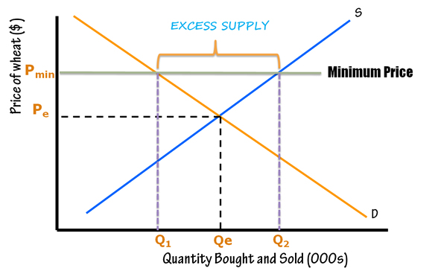
Fig. 8a: Minimum Price control

Effects of Minimum Price Control
- Surplus
When the price is set above the market price, producers have an incentive to produce larger quantities, a situation which results in excess supply or surplus of the commodity in question. Of course, consumers will not buy that many goods at the higher price and so those goods will go unsold.
- Black marketing
Prolonged surplus could create a black market, but may be less lucrative, where the goods are sold for less than the price floor. Though black markets are typically used to handle shortages or scarcity, it could be created in times of surplus too but may be less lucrative.

2.4.2 Maximum Price Control (Price Ceiling)
Maximum price control is a price control regime in which government fixes price below the equilibrium price above which no one can sell or buy. This is used to protect the interest of consumers of the said commodities. In Ghana, a closer example of a maximum price control is the tariffs on utilities such as electricity and water (see Fig. 8b)
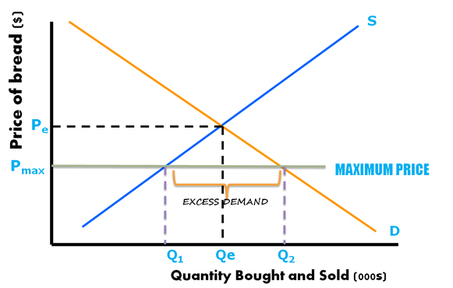
Fig. 8b: Maximum Price control

Effects of Maximum Price Control
- Shortage
Since a maximum price guarantees a lower price of the good in the market to consumers, obviously, a shortage will occur due to the excess demand over supply.
- Black marketing
Prolonged shortages caused by price ceilings can create black markets for that good. A black market is an underground network of producers that will sell to consumers as much of a controlled good as they want, but at a price higher than the price ceiling. Black markets are generally illegal. However these markets provide higher profits for producers and more of a good for the consumers, so many are willing to take the risk of fines or even imprisonment.
- Queuing and rationing
If a ceiling is to be imposed for a long period of time, a government may need to ration the good to ensure availability for the greatest number of consumers. One way the government may ration the good is to issue ticket to consumers. Government will only allow as much of good to be out in the marketplace as there are available tickets. To obtain the good, the consumer must present the ticket and the money to the vendor when making the purchase. This is generally considered a fair way to minimize the impact of a shortage caused by a ceiling, but is generally reserved for times of war or severe economic distress.

CHAPTER THREE

ELASTICITY OF DEMAND AND SUPPLY

3.0 What is Elasticity of Demand
Elasticity of demand is the degree of responsiveness of demand to changes in the price of the commodity in question (i.e. own price), prices of related goods (cross price) and the income of consumers. It can also be defined as a proportionate or percentage change in demand as a result of a proportionate or percentage change in own price, prices of other goods and the income of consumers. Both definitions yield the same outcome for elasticity of demand. Thus, from the definitions, three deductions can be made about elasticity of demand namely: the own price elasticity, cross price elasticity and income elasticity

3.1 Own Price Elasticity of Demand
The extent to which demand responds to changes in the price of the commodity in question (i.e. own price) is referred to as Own Price Elasticity of demand or simply Price Elasticity of demand. Price elasticity can be calculated mathematically at a point in time Point: This is expressed mathematically as:

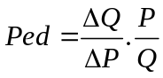 …….. (1)
Price Elasticity of Demand will always be negative because of the relationship between price and quantity.

3.1.1 Interpretations of own price elasticity of demand
- When |Ped| > 1
Type: Fairly elastic or simply elastic
Interpretation: A proportionate change in price leads to a more than proportionate change in quantity demanded.
- When |Ped| < 1
Type: Fairly inelastic or simply inelastic
Interpretation: A proportionate change in price leads to a less than proportionate change in quantity demanded.
- When Ped = 1
Type: Unitary elastic
Interpretation: A proportionate change in price leads to an equal proportionate change in quantity demanded.
- When Ped = ∞
Type: Perfectly elastic
Interpretation: At a constant price, quantity can change indefinitely
- When Ped = 0
Type: Perfectly inelastic
Interpretation: A proportionate change in price leads to no proportionate change in quantity demanded.

3.1.2 Determinants of Price Elasticity of Demand
- Availability of close substitutes: existence of close substitutes would make price elasticity more elastic and the vice versa.
- Proportion of income spent on the commodity: The more you spend a larger a proportion of income on the commodity, the more elastic is price elasticity of demand and reverse is also true.
- Duration for decision-making: If you have a longer time (long run) to make a decision on whether to buy the commodity, demand becomes more price elastic and the reverse is also true. In other words, price elasticity is more elastic in the long run and more inelastic in the short run.
- Nature of the commodity: Necessities such as food, shelter and clothing normally have inelastic demand compared with luxuries like mansions, private jets which have more elastic demand.

3.2 Cross-Price Elasticity of Demand
Cross Price Elasticity of demand refers to how demand tends to respond to changes in the prices of other related commodities.
Mathematically, we can express it as:

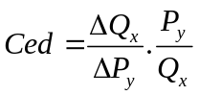…….. (2)

3.2.1 Interpretations of cross price elasticity of demand
- Ced > 0. The two commodities in question are substitutes.
- Ced < 0. The two commodities in question are complements.
- Ced = 0. The two commodities are neither complements nor substitutes

3.3 Income Elasticity of Demand
This is to measure how the quantity demanded of a commodity tends to respond to changes in the income of consumers. It is defined as the proportionate or percentage change in quantity demanded of a commodity as a result of a proportionate or percentage change in consumers’ income.
Point
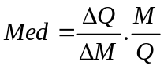 ….. (3)

3.3.1 Interpretations and policy implications of income elasticity of demand
- Med > 0. The commodity in question is a normal good. Sell more of a normal product as income level increase and the vice versa
- Med < 0. The commodity in question is an inferior. Sell less of an inferior product as income level increase and the vice versa
- Med = 0. The commodity in question is a necessity. Do not change the quantity of necessity products sold regardless of whether income level increases or falls

2.4 Price Elasticity of Supply
Price elasticity of supply is the degree or extent of responsiveness of supply to changes in the price of the commodity in question (i.e. own price). It can also be defined as a proportionate or percentage change in supply as a result in a proportionate or percentage change in own price. This is own price elasticity of supply or simply price elasticity of supply. Other aspects of elasticity of supply are beyond the scope of this edition.

Price elasticity of supply can be calculated mathematically at a point in time as:

Point
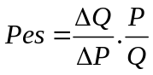 …….. (4)

3.4.1 Interpretations of own price elasticity of supply (Pes)
- When Pes > 1
Type: Fairly elastic or simply elastic
Interpretation: A proportionate change in price leads to a more than proportionate change in quantity supplied.
- When Pes < 1
Type: Fairly inelastic or simply inelastic
Interpretation: A proportionate change in price leads to a less than proportionate change in quantity supplied.
- When Pes = 1
Type: Unitary elastic
Interpretation: A proportionate increase in price leads to an equal proportionate fall in quantity supplied and the vice versa.
- When Pes = ∞
Type: Perfectly elastic
Interpretation: A proportionate increase in price leads to an infinite or tremendous fall in quantity supplied and the vice versa.
- When Pes = 0
Type: Perfectly inelastic
Interpretation: A proportionate increase in price leads to no proportionate change in quantity supplied.

Worked Example:
Suppose the following demand and supply functions relates to PZ Cussons (Ghana):
- Calculate the equilibrium price and quantity
- Calculate the quantity demanded, quantity supplied and the magnitude of surplus if a price floor of GH¢15 is imposed on the market.
- Calculate the price elasticity of supply and demand at the equilibrium price and quantity.
- Find the price that generates a unit price elasticity of supply and demand
- Find the price that generates an elastic price elasticity of supply and demand
- Find the price that generates an inelastic price elasticity of supply and demand
- Calculate the marginal revenue and total revenue at equilibrium.

Solution

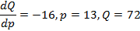  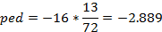  NB: use demand function when calculating ped | 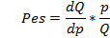  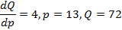  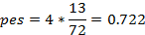  NB: use supply function when calculating pes
-16*(13/P) = -1  P=208 | - -16*(13/P) >-1  P > 208
- -16*(13/P) <-1
P < 208

g) Given price elasticity of demand (-2.889) and equilibrium price (13), MR is determined as follows:
This is positive as expected since demand is price elastic.

ASSIGNMENT
Question 1
Suppose the R&D department of MTN telecommunication estimates the following demand function for free-nights in March 2012.
Q = 4000 – 2.25P + 10.52C + 40X – W + 100M
Where Q = Demand for free-night calls; P = Price of free-night calls; C = Price of free-weekend calls; X = Price of family and friends; W = Price of international roaming and M = Income levels of clients. Given that (P, C, X, W, M) = (GHC 0.50, GHC 10, GHC 100, GHC 0.10, GHC 120).
- Calculate the price elasticity and comment on your answer
- Calculate and comment on the price elasticity between free-night calls and family and friends, free-night calls and international roaming, free-night calls and free-weekend call.
- What pricing strategy would you recommend to MTN so as to maximize revenue?
- Redo (a) – (c) assuming the prices of all these products doubled with the income levels of clients remaining unchanged
- Carefully explain why accountants are likely to overstate profits as compared to economists.

Question 2
A Kenkey seller operates in two markets. In market 1, research indicates that the price elasticity of demand is (-) 0.25 while that for market 2 is (-) 2.5. The seller has decided to reduce the price of Kenkey by 10% this month in both markets.
- Calculate the percentage change in quantity demand for Kenkey in both markets. Explain the result of the Kenkey seller’s action on the total revenue for both markets.
- Compute the marginal revenue for both markets if the price charged in market 1 and 2 are GH¢ 2 and GH¢ 1.50 respectively.
- As the firm’s adviser, suggest an alternative pricing strategy to the Kenkey seller.

Question 3
Suppose the demand and supply of Apple mobile phones are given by
Q = 500 – 8P and Q = 6P – 10
- Sketch the demand and supply functions for the Apple mobile phones
- Find the equilibrium market price and quantity demanded.
- Compute the consumer surplus and producer surplus
- What would happen if the government fixes a price ceiling of GH¢1?
- What would happen if the government fixes a price floor of GH¢3?
- Find the cost (to the government) of the price floor and price ceiling in (d) and (e) above?
- Suppose the income of consumers rises by GH¢10. What would the new equilibrium price and quantity be?

Question 4

The competitive market demand and supply for Multi TV in Ghana are:
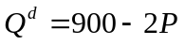 and 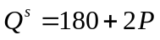
- Sketch the demand and supply functions for the Multi TV industry.
- Find the equilibrium market price and quantity demanded.
- Assume that a member of parliament (MP) raises a concern that the free market price might be too high for the ordinary Ghanaian to pay. Accordingly, she asks you to explain what would happen if they set a price ceiling at GH¢200. How would you answer?
- Suppose another MP is worried that the free market price is too low to enable producers to earn a fair rate of return. What would happen if the government agrees with him and buys Multi TV from suppliers at a price floor of GH¢340
- Suppose the income of consumers rises by GH¢70. What would the new equilibrium price and quantity be?
- If a fall in wages alters the market supply curve from 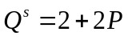 to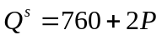, how would that affect the market-clearing price and quantity?
- Compute the price elasticity of demand and the price elasticity of supply at the equilibrium found in (b) – (f) and interpret your answers by suggesting appropriate policy actions necessary to increase revenue.
- Compute the price elasticity of supply at the market-clearing price and output found in (g).
- Compute the consumer surplus and producer surplus
- Find the cost (to the government) of the price floor in for the price controls assuming each is implemented at different times.
Question 5
At the 2010 board meeting of Guinness (Ghana) Limited, the production manager suggested that the company should buy more cans, bottles and sugar since he expects their prices to increase tremendously in 2014. The chief economist however disagreed on the grounds that, such a move is a violation of the normal law of demand. Carefully evaluate the correctness or otherwise of the opinion of the chief economist. In your opinion, should Guinness (Ghana) Limited follow the suggestion of the production manager? Explain your answer.

Question 6
Analyze the following policies and events using appropriate diagrams.
- Government of Ghana legalizes the consumption of marijuana. How does this affect the equilibrium price and quantity of marijuana?
- Suppose, Bank of Ghana directs the commercial banks to reduce the interest rate on loans. Would this directive affect the equilibrium interest rate and loan demand?
- Assume that, all automobile companies collude to increase the price of cars. Analyze how this collusion affects the equilibrium price and quantity of fuel.
- Unilever (Ghana) reduces the price of Pepsodent toothpaste. Show clearly how this affects the equilibrium price and quantity of close-up toothpaste.
- How would reduction of income tax affect the equilibrium price and quantity of goods and services in the country?
- Assume, government subsidizes the production of rLG mobile phones. Show how this move affects the equilibrium price and quantity of rLG mobile phones and laptops.
- A 20 hour curfew is imposed in Nima, a suburb of Accra from January to April. Would the curfew affect the equilibrium price and quantity of kenkey in Nima?
- Assume that, National Health Insurance Scheme is made compulsory for all citizens by an Act of Parliament. Analyze the effect on the equilibrium price and quantity of the NHIS identity card.
- How do you expect an increase in the price of cocoa beans to affect the equilibrium price and quantity of Milo and Chocolate
- Government of Ghana increases corporate tax to about 25% in 2012. What would be its effect on the equilibrium price and quantity of the services and products provided by the affected corporate bodies?

Question 7
Assume the following information relates to TTB in the year 2008. Study the table below carefully and answer the questions that follow.
% change in demand | % change in bank charges |  |  |  | % change in Income of clients
% change in demand | Current  A/C | Savings  A/C | Fixed deposit A/C | ATM  transactions | % change in Income of clients
Current A/C | -0.289 | 4.11 | 90.90 | 0.000 | 4.24
Savings A/C | 1.000 | -2.450 | -6.45 | 2.44 | -4.24
Fixed deposit A/C | -5.23 | 12.85 | -10.91 | -3.09 | 0.11
ATM transactions | -8.916 | 0.000 | -0.196 | -1.000 | 1.00

- Comment on the own price elasticity of demand
- What is the price elasticity of Current A/C resulting from a unit % change in bank charges of Savings A/C, Fixed deposit A/C, and ATM transactions?
- What is the price elasticity between Savings A/C and Current A/C, Savings A/C and Fixed deposit A/C, Savings A/C and ATM transactions?
- Comment on the income elasticity of demand for Current A/C, Savings A/C, Fixed deposit A/C and ATM transactions
- Discuss the prospects of these services assuming an economic expansion in Ghana.
- Which of these products of TTB would you advise management to increase or reduce its bank charges and why?

Question 8
Social commentators often argue that, government should rather tax luxuries more than it does for commodities like fuel which is so crucial to life and welfare. Critically examine why government in spite of its quest to improve welfare has a high inclination to impose heavy taxes on fuel than on luxuries.

CHAPTER FOUR

THEORY OF CONSUMER BEHAVIOUR

4.1 Who is a Consumer?
A consumer is an individual who purchases goods and services from firms for the purpose of direct consumption. In the preceding chapter, under the theory of demand, we realized that the normal demand curve slopes downward from left to right. The key focus of this chapter (i.e. theory of consumer behaviour) is to explain why the demand curve normally slopes downward from left to the right. That is, we establish why consumers buy more when the price is low and less when the price is high. Hence, this chapter discusses information on the behaviour of consumers. The main reason why a consumer will consume a good is because of the amount of satisfaction that the consumer derives from consuming the good. The amount of satisfaction a consumer derives from consuming a good is what we call utility. There are two main theories that help explain why people buy more if the price is low and vice versa. These are the Cardinalist Approach and the Ordinalist Approach. In this edition, we concentrate on the Cardinalist Approach. Before we explain the Cardinalist Approach, we make some key assumptions.

4.2 Assumptions
- The consumer is rational: In relation to this, the consumer always tries to maximize his utility from his limited resources (income) and minimize his disutility.
- The consumer should consume the same good.
- The consumer should consume a constant amount of the good
- Constant marginal utility of money: The additional utility derived from money is assumed to be constant. If not money will be inappropriate tool for measuring utility as postulated by the theory.

The proponents of the Cardinalist Approach believe that utility can be measured. Just like how heights of individuals can be measured in feet and weight in kilograms or pounds, we can measure utility in some units called utils. Since this approach can be measured in some units, we can have total utility, average utility and marginal utility.

4.3 Definitions of Key Concepts
Total Utility (TU): Total utility is the total amount of satisfaction or benefit that an individual gains from consuming a given amount of goods or services. It is the entire amount of satisfaction a consumer derives from consuming various units of a commodity. Note that which implies that

Average Utility (AU): It is the utility per unit of the commodity consumed per unit of time. Mathematically,
Marginal Utility (MU): Marginal utility is the additional satisfaction, or amount of utility gained from each extra unit of consumption. It is the satisfaction derived from consuming an additional unit of a commodity. Mathematically,

Will the total satisfaction you derive from consuming a good continue to as you consume more and more of a good? This question can be answered by first taking an example. Take, for example, an individual consuming chocolate bar. Let's say that after eating one chocolate bar your sweet tooth has been satisfied. Your marginal utility (and total utility) after eating one chocolate bar will be quite high. But if you eat more chocolate bars, the pleasure of each additional chocolate bar will be less than the pleasure you received from eating the one before - probably because you are starting to get full or you have had too many sweets for one day. This leads us to what we call the law of diminishing marginal utility.

The Law of Diminishing Marginal Utility: It states that “other things being equal”, as more units of a commodity is consumed marginal utility eventually falls. Although total utility usually increases as more of a good is consumed, marginal utility usually decreases with each additional units of consumption of a good. This decrease demonstrates the law of diminishing marginal utility. Because there is a certain threshold of satisfaction, the consumer will no longer receive the same pleasure from consumption once that threshold is crossed. In other words, total utility will increase at a slower pace as an individual increases the quantity consumed.

Graphical Illustration

Chocolate bars eaten | Marginal Utility | Total Utility
0 | 0 | 0
1 | 70 | 70
2 | 10 | 80
3 | 5 | 85
4 | 3 | 88

This table shows that total utility will increase at a much slower rate as marginal utility diminishes with each additional bar. Notice how the first chocolate bar gives a total utility of 70 but the next three chocolate bars together increase total utility by only 18 utils.

The law of diminishing marginal utility helps economists understand the law of demand and the negative sloping demand curve. The less of something you have, the more satisfaction you gain from each additional unit you consume; the marginal utility you gain from that product is therefore higher, giving you a greater willingness to pay more for it. Prices are lower at a higher quantity demanded because your additional satisfaction diminishes as you demand more.

It is clear from the discussion above that a consumer’s satisfaction will not increase indefinitely. So when will it be sensible for the consumer to stop the consumption of the good. This when we say the consumer is in equilibrium.

4.4 Equilibrium of the Consumer or Utility Maximization
The consumer is said to be in equilibrium or maximize utility at a point where he derives the highest possible level of satisfaction from consuming a particular commodity. At the equilibrium point there is no incentive for the consumer to consume further units of the commodity in question. Equilibrium condition of the consumer can be established in the case of one commodity:

- Analysis of Consumer equilibrium in the case of one commodity (single commodity) only
When it is assumed that the consumer is consuming only one commodity, then, consumer equilibrium is established when his marginal utility derived from consuming a particular commodity is equal to the value (price) of that commodity; Mathematically;
…………………………………….. (1)
Where, represents the marginal utility of the commodity in question (x) and Px is the price of commodity x in which case MU is being measured in monetary terms.

4.5 Disequilibrium of the Consumer and how it is restored
To explain why is the equilibrium condition, let us consider a state of disequilibrium. Using the single commodity approach: Assuming the increases, then (disequilibrium) which implies the price of the commodity becomes higher than its marginal utility. To restore the equilibrium, the rational consumer makes will consume less of the commodity. This will increase the marginal utility of the commodity until equilibrium is restored again. Thus, an increase in the price of a product has led to a reduction in quantity.
Conversely, assuming the price of commodity x falls, then (disequilibrium) and thus the price of the commodity becomes lower than before. To restore equilibrium, the rational consumer will increase his consumption of the commodity. With the law of diminishing marginal utility, this will reduce the marginal utility. Here again, a decrease in the price of a product has led to an increase in the consumption of commodity x. This is precisely what the law of demand says. At a high price, less of commodity x is bought, vice versa. We have been able to explain the law of demand with the concept of MU.

4.6 Paradox of Value
The paradox of value states that ‘if a commodity exists in a limited quantities it will have a high marginal utility hence attracting a higher value (price) since the quantity that will be available for consumption by the consumer is less whilst, if a commodity exist in an unlimited quantities consumers will have much to consume given rise to a lower marginal utility hence attracting a lower value (price)’.This explains why the price of Gold is higher than the price of water. Gold is uncommon and as such has a higher marginal utility and since the consumer equates marginal utility to price to establish equilibrium or maximize satisfaction, he will pay a higher price for Gold. On the other hand, water is very common and as such has a lower marginal utility and since the consumer equates marginal utility to price to establish equilibrium, he will pay a lower price for water.

ASSIGNMENT
Question 1
The table below shows the utility (satisfaction) profile of Lawrence Aboagye after consuming 10 units of Fan Milk Fan Ice Scream.
Quantity of Fan Ice Scream consumed | Marginal Utility (MU) | Total Utility (TU)
0 | - | 0
1 |  | 32
2 | 16 | 48
3 | 8
4 | 6 | 62
5 |  | 66
6 | 2 | 68
7 | 1
8 | 0
9 |  | 68
10 | -8

- Complete the table above and use it to answer the questions that follow
- Describe what happens to the marginal utility of Lawrence Aboagye as more units of Fan Ice scream are consumed.
- At what level of consumption does the law of diminishing marginal utility set in?
- What the peak of total utility?
- Depict the data in the table on a single graph sheet and outline the major differences you observe between TU and MU.

CHAPTER FIVE

THEORY OF PRODUCTION

5.0 Production
In the previous chapter we tried to understand the behaviour of consumers. In this chapter, what we want to understand is the Production is a very essential aspect in the business environment. It involves the activity of transforming inputs into output, be it finished or partly finished (i.e. work-in-progress). These inputs traditionally known as factors of production are labour, capital, land and entrepreneur. Usually, these four factors or inputs of production are reclassified into labour and capital where labour is defined to include entrepreneur and capital is also defined to include land.

5.1 Definition of Key Concepts

Short-Run
It is a production period in which at least one of the factors of production is fixed in nature e.g. land while others are variable e.g. labour. Thus, in the short-run, the firm is limited by capacity as it cannot vary the fixed inputs. In this regard, a firm is able to vary output by varying only its variable inputs such as labour.

Long-Run
In the long-run, however, all the factors of production can be varied with the level of output except technology. Thus, the period is long enough to enable the firm make all the necessary adjustment (i.e. adjust all inputs) to increase output.

Very Long-Run
This is a production period in which all the factors of production in addition to technology can be varied with the level of production.

Fixed Input or Factor:
A fixed input or factor is an input or factor of production whose quantity cannot be varied with the level of production example land, capital and managerial staff. Thus, whether output is increased or decreased, the quantity of fixed inputs remain unchanged

Variable Input or Factor
A variable input or factor is an input or factor of production whose quantity can be varied with the level of production example unskilled labour and raw material. Thus, the quantity of variable inputs increases as output increases, “all things being equal”.

Total Product
It refers to the entirety of quantity produced at any point in time. It is a horizontal summation of the quantity produced by all the workers (labour). It initially rises, attains a maximum and then begins to fall but would never be zero.

Marginal Product of Labour
This refers to a change in Total Product as a result of a unit change in labour. MP initially rises, attains a maximum and falls eventually to the extent that it can even attain zero values.
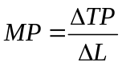

Average Product of Labour
It is the output per worker or labour. It initially rises, attains a maximum and eventually falls but never attaining zero values. APL = TP/L

5.2 Short-Run Production Analysis
Short-Run Law
Law of Diminishing Returns or the Law of Variable Proportions
This law posits that “other things being equal”, in the short-run, as successive units of a variable input such as labour are employed onto a fixed input such as capital, the Marginal product of the variable input rises, attains a maximum and falls eventually. By definition, this law is applicable only to the short run where at least, a factor or input is fixed in nature. It must be emphasized that all the short run product curves i.e. TP, AP and MP are inverted U-shaped due to this law. See Fig.10 below.

5.2.1 The Stages of Production
It is important to discuss the three stages in production.
Stage 1 (Irrational stage)
This stage starts from the origin and ends at where Average product (AP) is at its maximum and equal to Marginal product (MP). The stage is associated with rising Average product and Marginal product of labour. As long as both AP and MP continue to rise, it does not make economic sense for a producer to stop production at this stage of production and be satisfied with his level of output because there is still room for him to exploit further. That is, there are still some unexploited gains in his production activity and this is why we call it uneconomic stage. Also, there is too little variable input (labour) per unit of fixed input (capital) and it pays that the firm employs more labour to take advantage of the capital which, at this stage is relatively greater in terms of size than labour.

Stage 2 (Rational Stage)
This stage starts from where MP cuts the maximum of AP (i.e. AP is at its maximum and equal to MP) and ends at where MP equals to zero indicating all possible gains and advantages in the production process have been completely exhausted or exploited. Also, at this stage AP reaches its maximum and MP begins to fall. In spite of the falling MP, both AP and MP are still positive. This is the rational stage or economic stage as every producer is expected to operate since at this stage the producer has been able to exploit all gains completely.

Stage 3 (Irrational Stage)
This stage starts from where MP equals to zero and ends in the region where MP assumes negative values. It is also an irrational stage or uneconomic stage of production and a firm cannot operate at this stage since the contribution of additional workers to output (i.e. MP) is negative. Also, there is too much variable input (labour) per unit of fixed input (capital) and it pays that the firm has to reduce the employment of labour so as not to exert unnecessary pressure on the existing capital which, at this stage is relatively smaller in terms of size when compared to labour
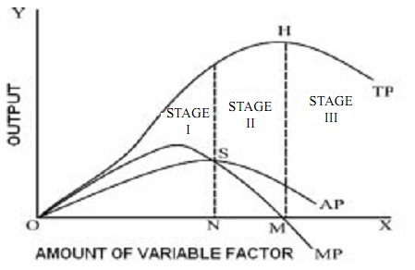
Fig. 10: Stages of Production

5.3 Key Relationship Between TP, AP and MP
- When TP is at its maximum, MP = 0
- MP cuts AP at the peak of AP
- AP never intersects or cuts the output (horizontal) axis
When TP begins to fall, MP begins to attain negative value

CHAPTER SIX

THEORY OF COST

6.0 Defining Cost
Now that we have understood production, we can now proceed to discuss cost. Cost is the expenditure incurred on the inputs or factors of production as the producer produces.

6.1 Short-Run Analysis of Cost
Recall that in the short-run analysis of the theory of production, it was established that at least, one input is fixed in nature (i.e. usually capital) and the other variable (i.e. usually labour). This stands to reason that, in the short run cost analysis too, there are two types of cost, namely: the fixed cost and variable cost.

Fixed Cost
This refers to the expenditure incurred on a fixed input and just as the fixed input does not vary with the level of production so is the fixed cost. Thus, it is constant throughout the various output levels and remains unchanged whether the firm produces or shuts down. See Fig 11 below:

Variable Cost
This refers to the expenditure incurred on a variable input and just as the variable input varies with the level of production so is the variable cost. Thus, it is increases at higher output levels and vice versa. See Fig 11 below:

Total Cost
In the short run Total Cost (TC) or simply Cost (C) is the summation of Total Fixed Cost (TFC) or simply Fixed Cost (FC) and Total Variable Cost (TVC) or simply Variable Cost (VC). It is crucial to note that TC = TFC when TVC = 0. See Fig 11 below:

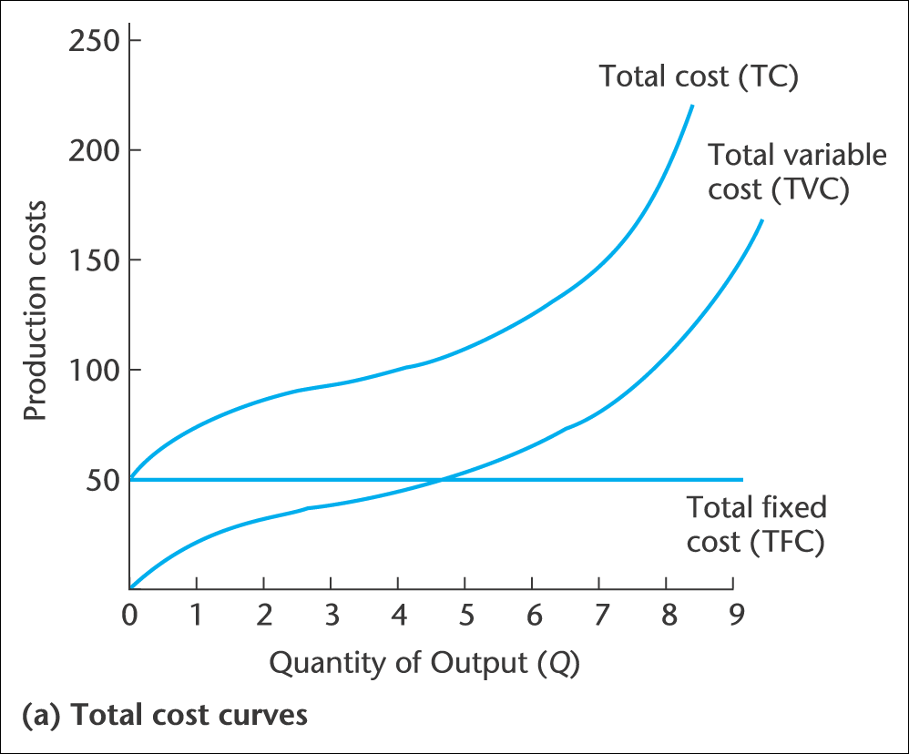
Fig. 11: Relationship between TC, TFC and TVC

Average Fixed Cost
It is defined as fixed cost per unit of output. That is, the fixed cost incurred on each output produced. The AFC declines as output increases. Mathematically, AFC = TFC/Q (see Fig. 12)

Average Variable Cost
It is defined as variable cost per unit of output. That is, the variable cost incurred on each output produced. Graphically, the AVC is U-shaped, that is, the AVC curve falls at initial levels of output and reaches a minimum at a certain level of production and beyond this level of production the AVC curve rises ultimately. In other words, at considerable lower output levels, AVC is quite high as the TVC is spread over smaller units of output. However, the firm increases it output level, AVC begins to fall. The U-shaped nature of the AVC curve comes from the law of diminishing returns.
Mathematically, AVC = TVC/Q. See Fig 12.

Average Total Cost
The Average Total Cost (ATC) or simply Average Cost (AC) refers to cost per unit of output. That is, the variable cost incurred on each output produced. Graphically, the ATC or AC is U-shaped just like the AVC. This implies that the AC curve falls at initial levels of output, it reaches a minimum at a certain level of production and beyond this level of production, and the AC curve rises ultimately. In other words, at considerable lower output levels, AC is quite high as the TC is spread over smaller units of output. However, the firm increases it output level, AC begins to fall. The AC tends to rise when the law of diminishing return begins to operate. Mathematically, AVC = TC/Q. Also, AC = AFC + AVC. See Fig 12.

Marginal Cost
The Marginal Cost (MC), sometimes called the Marginal Variable Cost (MVC) is defined as change in total cost as a result of producing one additional unit of output. The MC is an important cost concept because it helps the firm to estimate the cost it would incur to expand its production capacity (i.e. produce one additional unit of output). Graphically, the MC just like the AVC and AC is U-shaped. Thus, the MC curve falls at initial levels of output, it reaches a minimum at a certain level of production and beyond this level of production the MC curve rises ultimately. The MC tends to rise when the law of diminishing returns begins to operate. Mathematically, 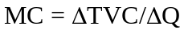 or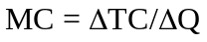. See Fig 12.

6.2 Key Relationship between AVC, AC and MC
- AVC, AC and MC are all U-shaped due to the law of diminishing returns
- AVC being lower than AC in magnitude implies that the AVC curve lies below the AC curve and the vertical distance between the AVC and AC curve is AFC. (Note: AC =AFC+ TVC and thus, AFC = AC – AVC).
- When both AVC and AC are falling, AVC falls faster than AC. Similarly, when they are rising AVC rises faster than AC. As a result, AVC attains its minimum before AC. In other words, the minimum of AVC occurs at a lower output than the minimum of AC.
- The vertical distance between AVC and AC has been established in (2) above to be the AFC. This distance is wider when both AVC and AC are falling but this vertical distance diminishes as they both tend to rise. This is due to the rectangular hyperbola and asymptotic nature of AFC.
- When AVC, AC and MC are all falling due to the law of diminishing returns, MC falls faster than AVC and AVC also falls faster than AC. Similarly, when AVC, AC and MC are rising due to the law of diminishing returns, MC rises faster than AVC and AVC also rises faster than AC. As a result, MC attains its minimum before AVC attains its minimum and AVC also attains its minimum before AC. In other words, the minimum of MC occurs at a relatively lower output level than AVC, while the minimum of AVC also occurs at a lower output than the minimum of AC. See Fig 12 which diagrammatically summarizes the relationship between AVC, AC and MC.
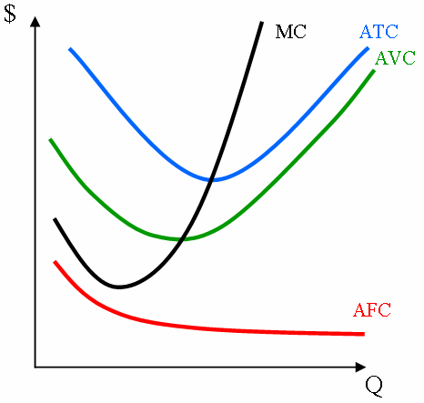

Fig. 12: Relationship between AVC, AC and MC

ASSIGNMENT

Questions 1
Consider a firm in a perfectly competitive industry. The firm has just built a plant that cost GHC 25,000. Each unit of output requires GHC 5 worth of materials. Each worker costs GHC 5 per hour.
- Based on the information above, fill in the table below.
Hours of work | Output | TFC | TVC | TC | MC | AVC | ATC
0 | 0
25 | 100
50 | 150
75 | 175
100 | 195
125 | 205
150 | 210
175 | 212

Where TFC is Total Fixed Cost
TVC is Total Variable Cost
TC is Total Cost
MC is Marginal Cost
AVC is Average Variable Cost
ATC is Average Total Cost
- If the market price is GHC 10, how many unit of output will the firm produce.
- At that price, what is the firm’s profit or loss? Will the firm continue to produce in the short run? Carefully explain your answer.

Question 2
One of the development challenges of Africa is Food insecurity but Economists assert that, had it not been for the law of diminishing marginal returns, the whole world food supply could be produced in a flower pot. Discuss the validity of this assertion in the context of food security issues in Africa.

Question 3
The table below represents the production and cost schedule of a firm producing ice cream in a particular month.

K | L | MP | TFC | TVC | TC | AFC | ATC | AVC | MC
10 | 0 | - |  |  | 500
 | 1 | 10
 | 2 | 15
 | 3 | 20 |  |  | 560
 | 4 | 25
 | 5 | 30
 | 6 | 15
 | 7 | 10
 | 8 | 7

Suppose the monthly rental cost of capital is GHC50 and the monthly compensation for the average employee is GHC20.
- Fill in all the blank spaces in the above table.
- After what unit of labour does diminishing return set in?
- At what level of output is ATC minimized? At what level of output is AVC minimized
- Graph your results for ATC, AVC and MC on the same graph.

ANSWER TIPS
Question 1

Hrs of Work | Output | TFC | EOW | EOM | TVC | TC | MC | AVC | ATC
0 | 0 | 25000 | 0 | 0 | 0 | 25000 | - | - | -
25 | 100 | 25000 | 125 | 500 | 625 | 25625 | 6.25 | 6.25 | 256.25
50 | 150 | 25000 | 250 | 750 | 1000 | 26000 | 7.50 | 6.67 | 173.33
75 | 175 | 25000 | 375 | 875 | 1250 | 26250 | 10 | 7.14 | 150
100 | 195 | 25000 | 500 | 975 | 1475 | 26475 | 11.25 | 7.56 | 135.77
125 | 205 | 25000 | 625 | 1025 | 1650 | 26650 | 17.50 | 8.05 | 130
150 | 210 | 25000 | 750 | 1050 | 1800 | 26800 | 30 | 8.57 | 127.62
175 | 212 | 25000 | 875 | 1060 | 1935 | 26935 | 67.50 | 9.13 | 127.05

EOW =Expenditure on Workers = No. of Hrs * Wages/per hour
EOM = Expenditure on Materials = Output* material cost
TVC = EOW + EOM
MC = ∆TC/∆Q
AVC= TVC/Q
ATC=TC/Q
(b) Profit-maximizing Output = 175
(c)
i. Profit/Loss= TR-TC
But TR=P.Q = 10*175= 1750; and TC=26250
Profit/Loss = 1750 – 26250
Hence; Loss = 24500

ii. The firm would continue to produce in the short run because price at that level is greater than the corresponding average variable cost (AVC). This is because, in the short run, the decision to produce depends on price and AVC and not whether the firm makes profit or loss. In this question, at the profit maximizing level Price ˃AVC, and thus, the firm should continue to produce.

Question 6

Note that total output (Q) at any level of employment of labour is equal to the cumulative summation of the MP up to that level of labour employment
a)
K | L | MP | TFC | TVC | TC | AFC | AVC | ATC | MC | Q
10 | 0 | - | 500 | - | 500 | - | - | - | -
10 | 1 | 10 | 500 | 20 | 520 | 50 | 2 | 52.00 | 2 | 10
10 | 2 | 15 | 500 | 40 | 540 | 20 | 1.6 | 21.60 | 1.33 | 25
10 | 3 | 20 | 500 | 60 | 560 | 11.11 | 1.33 | 12.44 | 1 | 45
10 | 4 | 25 | 500 | 80 | 580 | 7.14 | 1.14 | 8.29 | 0.8 | 70
10 | 5 | 30 | 500 | 100 | 600 | 5 | 1.00 | 6.00 | 0.67 | 100
10 | 6 | 15 | 500 | 120 | 620 | 4.35 | 1.04 | 5.39 | 1.33 | 115
10 | 7 | 10 | 500 | 140 | 640 | 4 | 1.12 | 5.12 | 2 | 125
10 | 8 | 7 | 500 | 160 | 660 | 3.75 | 1.21 | 5.00 | 2.86 | 132

b) The law of diminishing marginal begins to set in after the 5th unit of labour was employed this is because after this unit the MP fell from its maximum value which was 30 to 15.

c) ATC is minimized at an output level where it attained it lowest possible value in production. Hence from the table, output 115 minimizes ATC. Similarly, output 132 is the output which minimizes AVC of the firm.
d) AFC, AVC, ATC and MC graphs
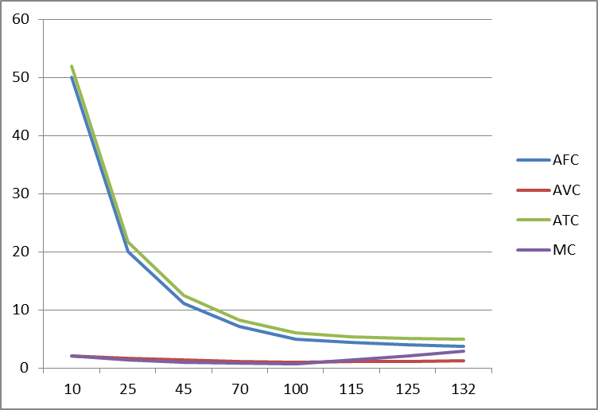

CHAPTER SEVEN

MARKET STRUCTURES

7.1 Introduction
Now that we have understood cost, we can now select the output and price that will help a firm maximize its profit. But before that, remember that profit is made up of revenue and cost. Hence, it is important for us to briefly discuss the concept of revenue. Some firms have control over the price of their products whilst some do not have any control over the price of their products. The firms that have control over the price of their products we call them price-makers and those that do not have control over the price of their products we call price takers. Let us now examine how the different measures of revenue vary with output.

7.1.1 Price Takers
As discussed earlier, price-takers have no influence over the price of their products and therefore the average revenue, marginal revenue, price and the demand curve are all equal. They are constant and do not vary with price. Below, we show the relationship between the different measures of revenue and output.

Table 6.1: Relationship between measures of revenue and output for price takers

Price | Output | Total Revenue | Average Revenue | Marginal Revenue
5 | 1 | 5 | 5 | 5
5 | 2 | 10 | 5 | 5
5 | 3 | 15 | 5 | 5
5 | 4 | 20 | 5 | 5
5 | 5 | 25 | 5 | 5
5 | 6 | 30 | 5 | 5
5 | 7 | 35 | 5 | 5

It is clear from table 6.1 above that irrespective of the output being produced, price remains same for price-takers. From the table above, both marginal revenue and average revenue are equal to price and they do not vary with output. Hence, the demand curve which is also the price curve is horizontal for price takers

7.1.2 Price Makers.

Remember price makers do have some control over the price of their products. For them, to sell more, they need to reduce their price. This means that both their marginal revenue and their average revenue curves (price curve or demand curve) will always be downward sloping but price is always bigger than the marginal revenue. Refer to table 6.2 below for the relationship between the different measures of revenue and output.

Table 6.2: Relationship between measures of revenue and output for price makers

Price | Output | Total Revenue | Marginal Revenue | Average Revenue
10 | 1 | 10 | - | 10
9 | 2 | 18 | 8 | 9
8 | 3 | 24 | 6 | 8
7 | 4 | 28 | 4 | 7
6 | 5 | 30 | 2 | 6
5 | 6 | 30 | 0 | 5
4 | 7 | 28 | -2 | 4

It is evident from the table above that price once again will always be equal to average revenue. However, although both price and marginal and marginal revenue are falling as output increases, at each level of output, price is greater than marginal revenue.

7.2 Definition of Some Key Concepts
Profit
Profit is the excess of total revenue (or simply revenue) over total cost (or simply cost). It can also be defined as the difference between revenue and cost. There are three types of profit, namely: supernormal profit, normal profit and subnormal profit.

Normal Profit
The normal profit is the minimum profit that is required for a firm to keep operating in an industry. It is sometimes called zero economic profit or simply breakeven. It is when total revenue (TR) is equal to total cost (TC). It also occurs when average revenue (AR) which is the same as price (P) is equal to average cost (AC). Thus, Normal Profit= AR = AC

Supernormal Profit
The supernormal profit is the profit over and above the normal. It is sometimes called abnormal profit or positive economic profit or pure profit or simply profit, is when total revenue (TR) exceeds Total cost (TC). It also occurs when average revenue (AR) which is the same as price (P) is greater than average cost (AC). Thus, Supernormal Profit = AR > AC.

Sub-Normal Profit
The subnormal profit, also called losses is that profit below the normal. It also occurs when average revenue (AR) which is the same as price (P) is less than average cost (AC). Subnormal Profit = AR < AC.

Profit Maximization Rule (Equilibrium of the Firm)
In traditional economics, the goal of every firm is to maximize profit. A firm maximizes profit when it operates at a point where it achieves the highest possible profit. At this point there is no incentive for the firm to expand. The thumb rule for profit maximization irrespective of the market structure is achieved when Marginal Revenue (MR) is equal to Marginal Cost (MC). This equilibrium is valid in both the short-run and long-run. Mathematically, in equilibrium, MC = MR. Though is the necessary condition, it is not sufficient for a firm to stop production. The sufficient condition is given as: MR = MC and MC is rises just beyond this point.

With a clear understanding of revenue and cost, we can now move on to market structure where we will select the price and output that will help firms maximize profits. Remember that a firm producing cars for instance is different from a firm producing notebooks. Since there are different firms in the real world, the price and the output that will maximize profit in one firm will not be the price and output that will maximize profit in another firm. Hence, it is important to bring together all the firms that look like the car industry and also group together all the firms that look like the book industry. This can be done using certain criteria. These criteria include:

- Conditions of entry and exit
- Number of buyers and sellers
- The firm’s ability to control prices
- The nature of the product traded in the market
- Availability of knowledge in the market

7.3 Types of Market Structures
Based on the criteria above, we end up with 4 main markets. These are Perfect Competition, Monopoly, Monopolistic Competition and Oligopoly. At our level, we would distinguish between two (2) main types of market structures based on the above criteria. These are:
- Perfect competition
- Monopoly

7.3.1 PERFECT COMPETITION
A market is said to be perfectly competitive when the following assumptions hold in the said market or when the market possesses the following characteristics:
- Firms or sellers seek to maximize profit
- Free entry and exit
- Many Small firms
- Homogenous products are sold and bought.
- Both sellers and buyers have perfect knowledge about everything that pertains to their interest
- Perfect mobility of resources.
- No government interventions. Prices are always fixed by demand and supply conditions i.e. prices are always fixed by consumers and sellers.
- Absence of collusion
- As a result of assumptions (ii), (iii) and (iv), both sellers and buyers are unable to control prices. Hence, buyers and more especially, sellers are said to be price-takers. The demand (price) curve of firms in a perfectly competitive market is horizontal to the quantity axis.

7.3.1.1 Short-Run Equilibrium and Profit Analysis of Firms in Perfect Competition
Recall that for a firm in a perfectly competitive market to be in equilibrium, MC = MR (more specifically, MC = MR = AR = P). In the short-run, a firm in a perfectly competitive market can make any of the three different types of profit discussed above (see Figure 13, 14 and 15) depending on its cost structure and level of efficiency. If cost/expenditure is not properly managed and it exceeds revenue the sellers in a perfectly competitive market can make massive losses and can even shut down. This stands to reason that, the fact that the firm is in a perfectly competitive market competing with so many firms in the industry does not mean that it would always break-even or make a loss.

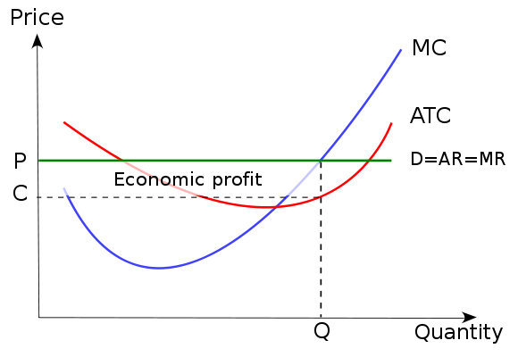
Fig. 12: Supernormal of a firm under Perfect Competition

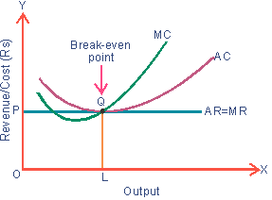
Fig. 14: Normal profit of a firm under Perfect Competition

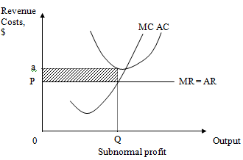

Fig. 15: Subnormal profit of a firm under Perfect Competition

7.3.1.2 Long-Run Equilibrium and Profit Analysis of Firms in Perfect Competition
In the long-run, all firms under perfect competition can earn only normal profit. This is because of the assumption of free entry and exit. If pre-existing firms were making super normal profit in the short-run and this persists to the long-run then because of free entry new firms will be attracted into the industry to compete the super-normal profit until a point where each firm will be earning normal profit. On the other hand if the pre-existing firms were making sub-normal profit in the short-run and this persist to the long-run then because of free exit some of the losing firms will leave the industry. As a result their share of profit will be distributed among the rest of the remaining few firms until a point where each firm will be making normal profit. Graphically, this is depicted by Fig. 16.

Fig. 16: Long-run Normal profit of a firm under Perfect Competition

7.3.2 MONOPOLY
A Monopoly is a market structure in which there is one seller or producer of a product with no close substitute but with many buyers. Other features include;
- No freedom of entry i.e. there are barriers to entry
- The monopoly sells more at lower prices and sells few at higher prices.
- Hence, a monopolist faces a downward sloping price (demand) curve with its marginal revenue (MR) curve lying below the price (demand) curve. In fact, beyond a certain price level, the MR can assume negative values.

7.3.2.1 Factors That Give Rise to Monopoly or Sources of Monopoly’s Power
- Patent and copyright: Patents reward firms for investing millions of dollars in research and development of new products. They give a company the sole right to produce the product for a limited time period in order to help it recoup the research and development costs. Examples of patents include a pharmaceutical company’s exclusive right to sell a medication or a chemical company having exclusive rights to sell a chemical it has developed. Firms will often use those profits to research and develop new products. Similar to patents, copyrights grant exclusive rights for products developed by firms such as films or books. Finally, licenses granted by the government restrict the number of firms in an industry
- Legislative protection: Governments often control essential services in a city such as water, sewer, and garbage. If all households are required to have garbage service and the government grants the contract to one firm, that firm would have a monopoly. For instance, the Electricity Company of Ghana has been made a monopolist in the transmission of hydro-electric power in Ghana through an Act of Parliament.
- Possession or control of strategic raw materials or skills: Another barrier to entry can occur when firms are able to own or control the necessary inputs or resources, and as a result, they may be able to control the market. For instance, In the 1940s the Aluminum Co. of America, U.S.A had monopoly power by controlling the mineral bauxite, an essential input for making aluminum.
- Economies of Scale: In certain industries natural monopolies exist where the long run average cost curve continues to decline in the relative region of demand. Consequently, one firm is able to produce enough for the market at a lower per unit cost than would be the case if two firms shared the market. In this case, positive profits can exist, but entrants cannot enter to capture some of these profits because sharing the market means they have to enter at a smaller scale of operation and thus face higher average costs. The transmission of electricity is an example of a natural monopoly.
- Initial capital requirement and market size

7.3.2.2 Short-Run Equilibrium and Profit Analysis of a Monopolist
Recall that for a monopolist to be in equilibrium, MC = MR. Furthermore, notice that as long as the monopolist can sell more only at lower prices and sells few at higher prices; it faces a downward sloping demand (price) curve with its marginal revenue (MR) curve lying below the demand (price) curve. In fact, beyond a certain price level, the MR can assume negative values. In the equilibrium of the firm in the short-run, the monopolist can make any of the three different types of profit discussed above (i.e. supernormal profit, normal profit and subnormal profit) depending on its cost structure and level of efficiency. If cost/expenditure is not properly managed and it exceeds revenue, the monopolist though the sole seller can make massive losses. This stands to reason that, the fact that the monopolist is the only firm in the industry does not mean it always get profit. See Fig. 17, 18 and 19 as follows:

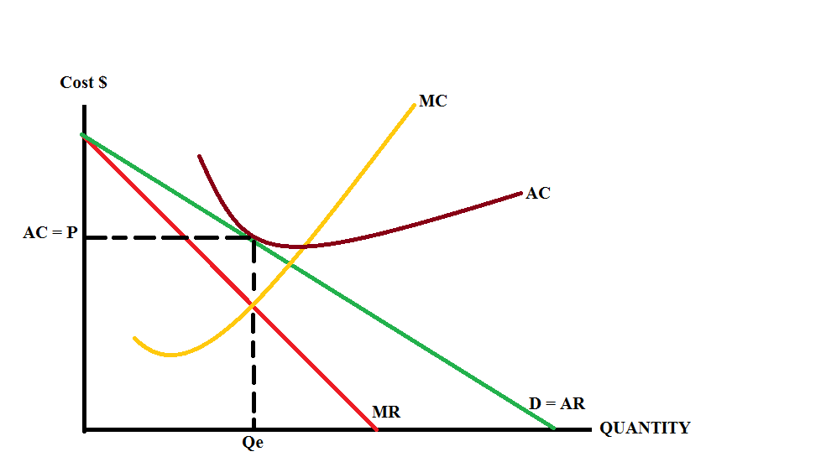
Fig. 17: Normal /Breakeven profit of a monopolist

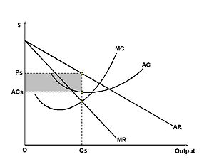
Fig. 18: Supernormal /Economic Profit of a monopolist (shaded region)

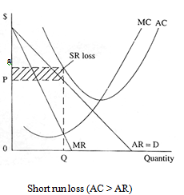
Fig. 19: Sub-normal Profit /Losses of a monopolist (shaded region)

7.3.2.3 Long-Run Equilibrium and Profit Analysis of a Monopolist
Unlike the perfect competitor, in the long-run, the monopolist is in equilibrium when MC = MR, and due to the existence of barriers to entry, the monopolist could maintain supernormal. Graphically, this is depicted by Fig. 18. However, it can make losses and even get to a shut - down position if its firm is not properly run.

Fig. 20: Long-run Normal /Breakeven Profit

CHAPTER EIGHT

MAJOR MACROECONOMIC VARIABLES

8.0 Introduction
Macroeconomic variables are indicators of the overall state of a country's economy. Macroeconomic variables are indicators or main signposts signalling the current trends in the economy. Notable among the major macroeconomic variables include but not limited to economic growth, inflation, unemployment, interest rate, exchange rate, balance of payments, fiscal budget, public debt. However, given the scope of this level we look at only three of these major macroeconomic variables or indicators. Also, since this book is essentially an introductory book to economics, discussions center on very fundamental aspects of these major macroeconomic indicators or variables.

8.1 ECONOMIC GROWTH
The concept of economic growth is very broad. It has attracted the attention of many researchers and has been defined in various ways by economists.

8.1.1 What is Economic growth?
Most commonly, economic growth is defined as an increase in the output that an economy produces over a period of time. Better still, Economic growth means an increase in real Gross Domestic Product (GDP) of an economy. This increase in real GDP means there is an increase in the value of national output / national expenditure. Economic growth could also imply the increase in real GDP per capita. Further, economic growth is considered as an increase in what an economy can produce if it is using all its scarce resources. An increase in an economy’s productive potential can be shown by an outward shift in the economy’s production possibility frontier (PPF). The appropriateness of each of these definitions may depend on what the growth rate is intended to capture.

8.1.2 Economic growth and business cycle
From a conceptual perspective, the business cycle is the upward and downward movements of levels of GDP (gross domestic product) and refers to the period of expansions and contractions in the level of economic activities (business fluctuations) around a long-term growth trend.

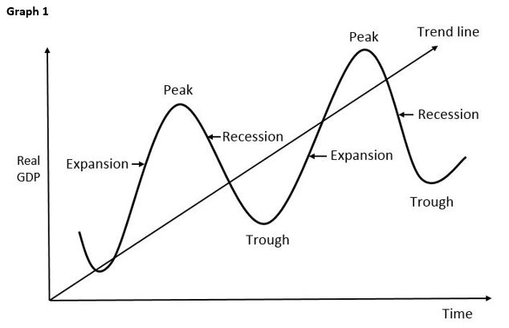
Fig. 21: Business Cycle

Types of business Cycle

- Expansion: A speedup in the pace of economic activity defined by high growth, low unemployment, and increasing prices. The period marked from trough to peak. The early stages of an expansion is referred to as recovery
- Peak: The upper turning point of a business cycle and the point at which expansion turns into contraction. The peak of the cycle also represents the point in time when economic activity temporarily is at a maximum. The highest peak an economy’s growth process may be referred to as a boom.
- Contraction/Recession: the recession is a phase usually following a peak or preceding a trough. It represents a slowdown in the pace of economic activity defined by low or stagnant growth, high unemployment, and declining prices. It is the period from peak to trough. A recession occurs if a contraction is severe enough. A prolong period of recession is called depression.
- Trough: the trough is the point where output is at its lowest level. Naturally, a trough follows a recession or depression

Causes of Business Cycle

- Momentum effect. When there is positive economic growth, this tends to cause: a rise in consumer and business confidence
- Rising asset prices such as houses; this causes a rise in wealth and consumer spending.
- Interest Rate Changes. When there is higher economic growth, inflation tends to rise. In response, Central Banks tend to increase interest rates to reduce growth and inflation.
- Technology. Improvements in technology may cause a boost in economic growth. A lull in technological innovation may cause slower growth.
- Political Business cycle. Some economists suggest that there is a political business cycle. This is when politicians try to have a boom (high economic growth) before an election to help win the election.
- Global Trade Cycle. A global economic downturn will tend to affect individual economies.

8.1.3 Sources or Causes of Economic growth
The sources of economic growth are enormous but could be conveniently categorized into demand and supply side sources. This implies that economic growth could either emanate from the demand side of the economy or the supply side. It is worth-noting that there are other sources of economic growth other than demand and supply sides

Demand side causes
In the short term, economic growth is caused by an increase in aggregate demand (AD). AD is the sum of demand or expenditure on goods and services made by various economic agents including households, government, and firms among others. If there is spare capacity in the economy then an increase in AD will cause a higher level of real GDP. AD can be increased through
- Increased wages. Higher real wages increase disposable income and encourages consumer spending.
- Increased government spending e.g. government investment on building new roads.
- Fall in value of sterling which makes exports cheaper and increases quantity of exports
- Increased consumer confidence, which encourages spending
- Lower income tax which increases disposable income of consumers and increases consumer spending
- Rising house prices, which create a positive wealth effect and encourages homeowners to spend more
- Lower interest rates. This is because lower interest rates reduce the cost of borrowing and so encourages spending and investment.

Supply side causes
- Increased capital. E.g. investment in new factories or investment in infrastructure, such as roads and telephones.
- Increase in working population, e.g. through immigration, higher birth rate.
- Increase in labour productivity, through better education and training or improved technology.
- Discovering new raw materials.
- Technological improvements to improve the productivity of capital and labour e.g. Microcomputers and the internet have both contributed to increased economic growth.

Other factors affecting economic growth
- Economic and political stability. Stability is important for reassuring firms it is a good idea to invest in increasing capacity. If we see a rise in uncertainty, confidence tends to fall and this can cause firms to delay investment.
- Low inflation. Low inflation is a good climate for encouraging business investment. High inflation increases volatility.

8.1.4 Benefits of economic growth
The benefits of economic growth include:
- Higher average incomes. This enables consumers to enjoy more goods and services and enjoy better standards of living.
- Lower unemployment: with higher output and positive economic growth firms tend to employ more workers creating more employment.
- Lower government borrowing. Economic growth creates higher tax revenues and there is less need to spend money on benefits such as unemployment benefit. Therefore economic growth helps to reduce government borrowing. Economic growth also plays a role in reducing debt to GDP ratios.
- Improved public services. With increased tax revenues the government can spend more on public services, such as the NHIS and education etc.
- Money can be spent on protecting the environment. With higher real GDP a society can devote more resources to promoting recycling and the use of renewable resources
- Investment: Economic growth encourages investment and therefore encourages a virtuous cycle of economic growth.

8.1.5 Potential costs of economic growth
Despite the benefits of economic growth, there are also potential costs, such as inflation, a current account deficit, environment costs and widening inequality.
However, the costs of economic growth will depend on the type of growth that we see. Potential costs of economic growth include:
- Inflation. If AD increases faster than AS then economic growth will be unsustainable. Economic growth tends to cause inflation when the growth rate is above the long run trend rate of growth. It is when demand increases too quickly that we get a positive output gap and firms push up prices.
- Boom and bust economic cycles. If economic growth is unsustainable then high inflationary growth may be followed by a recession. For instance, in UK, during the 1980s there was an economic boom with growth of over 5% a year. However this caused inflation to rise to over 10%. To reduce inflation the government increased interest rates, this caused the economy to slow down and then enter into a recession.
- Environmental costs: Increased economic growth will lead to increased output and therefore increased pollution and congestion. This will cause health problems such as asthma and therefore will reduce the quality of life. Economic growth also means greater use of raw materials and can speed up depletion of non-renewable resources.
- Inequality: Higher rates of economic growth have often resulted in increased inequality because growth can benefit a small section of society more than others. For example, those with assets and wealth will see a proportionally bigger rise in the market value of rents and their wealth. Those unskilled without wealth may benefit much less from growth. However it depends upon things such as tax rates and the nature of economic growth. Economic growth can also be a force for reducing absolute and relative poverty.

8.2 INFLATION

8.2.1 Defining Inflation
In economics, inflation is a sustained increase in the general price level of goods and services in an economy over a period of time.

8.2.2 Types of Inflation
The types of inflation discussed here relate more to the rate of speed or intensity in the change of price

- Creeping or Mild Inflation: If the speed of upward thrust in prices is slow but small then we have creeping inflation. The speed of annual price rise that is considered to be a creeping one has not been stated by economists. To some, a creeping or mild inflation is one when
- Annual price rise varies between 2 % and 3 %. If a rate of price rise is kept at this level, it is considered to be helpful for economic development.
- Walking Inflation: If the rate of annual price increase lies between 3 % and 4 %, then we have a situation of walking inflation. When mild inflation is allowed to fan out, walking inflation appears. These two types of inflation may be described as ‘moderate inflation’.
- Galloping and Hyperinflation: Walking inflation may be converted into “running” inflation. Running inflation is not a very good thing. If it is not controlled, it may ultimately be converted to galloping or hyperinflation. Inflation in the double or triple digit range of 20%, 100% or 200% a year is labelled “galloping inflation”.

8.2.3 Causes of Inflation
1. Demand pull inflation

This occurs when AD increases at a faster rate than AS. Demand-pull inflation occurs when demand for a good or service outstrips supply. As demand increases, sellers start selling out of the product, and frustrate potential customers. Their next step would be to produce more. If supply cannot keep up, their next step would be to raise prices, creating inflation. Demand pull inflation will typically occur when the economy is growing faster than the long run trend rate of growth. As earlier mentioned, if demand exceeds supply, firms will respond by pushing up prices.

What are the main causes of Demand-Pull Inflation?
- Increase in fiscal expenditure. e.g. lower direct or indirect taxes or higher government spending. If direct taxes are reduced, consumers have more disposable income causing demand to rise. Higher government spending and increased borrowing creates extra demand in the circular flow
- Monetary expansion: A fall in interest rates may stimulate too much demand – for example in raising demand for loans leading inflation. Monetarist economists believe that inflation is caused by “too much money chasing too few goods" and that governments can lose control of inflation if they allow the financial system to expand the money supply too quickly.
- Increase in wages and salaries

2. Cost push inflation

This occurs when there is an increase in the cost of production for firms causing aggregate supply to shift to the left. Cost push inflation could be caused by rising energy and commodity prices. Cost-push inflation occurs when firms respond to rising costs by increasing prices in order to protect their profit margins.

What are the main causes of Cost-Push Inflation?
There are many reasons why costs might rise:
- Component costs: e.g. an increase in the prices of raw materials and other components. This might be because of a rise in commodity prices such as oil, copper and agricultural products used in food processing. A recent example has been a surge in the world price of wheat.
- Rising labour costs - caused by wage increases, which are greater than improvements in productivity. Wage costs often rise when unemployment is low because skilled workers become scarce and this can drive pay levels higher. Wages might increase when people expect higher inflation so they ask for more pay in order to protect their real incomes. Trade unions may use their bargaining power to bid for and achieve increasing wages, this could be a cause of cost-push inflation
- Higher indirect taxes – for example a rise in the duty on alcohol, fuels and cigarettes, or a rise in Value Added Tax (VAT). Depending on the price elasticity of demand and supply for their products, suppliers may choose to pass on the burden of the tax onto consumers.
- A fall in the exchange rate – this can cause cost push inflation because it leads to an increase in the prices of imported products such as essential raw materials, components and finished products
- Monopoly employers/profit-push inflation – where dominants firms in a market use their market power (at whatever level of demand) to increase prices well above costs

8.2.4 Effects of Inflation
Many governments have set their central banks a target for a low but positive rate of inflation. They believe that persistently high inflation can have damaging economic and social consequences.
- Income redistribution: One risk of higher inflation is that it has a regressive effect on lower-income families and older people in society. This happen when prices for food and domestic utilities such as water and heating rises at a rapid rate

- Shoe leather cost: High inflation increases the opportunity cost of holding cash balances and can induce people to hold a greater portion of their assets in interest paying accounts. However, since cash is still needed in order to carry out transactions this means that more "trips to the bank" are necessary in order to make withdrawals, proverbially wearing out the "shoe leather" with each trip.
- Menu costs: With high inflation, firms must change their prices often in order to keep up with economy-wide changes. But often changing prices is itself a costly activity whether explicitly, as with the need to print new menus, or implicitly, as with the extra time and effort needed to change prices constantly.
- Falling real incomes: With millions of people facing a cut in their wages or at best a pay freeze, rising inflation leads to a fall in real incomes.
- Negative real interest rates: If interest rates on savings accounts are lower than the rate of inflation, then people who rely on interest from their savings will be poorer.
- Cost of borrowing: High inflation may also lead to higher borrowing costs for businesses and people needing loans and mortgages as financial markets protect themselves against rising prices and increase the cost of borrowing on short and longer-term debt. There is also pressure on the government to increase the value of state pensions and unemployment benefits and other welfare payments as the cost of living climbs higher.
- Risks of wage inflation: High inflation can lead to an increase in pay claims as people look to protect their real incomes. This can lead to a rise in unit labour costs and lower profits for businesses.
- Business competitiveness: If one country has a much higher rate of inflation than others for a considerable period of time, this will make its exports less price competitive in world markets. Eventually this may show through in reduced export orders, lower profits and fewer jobs, and also in a worsening of a country’s trade balance. A fall in exports can trigger negative multiplier and accelerator effects on national income and employment.
- Business uncertainty: High and volatile inflation is not good for business confidence partly because they cannot be sure of what their costs and prices are likely to be. This uncertainty might lead to a lower level of capital investment spending.
Overall, a high and volatile rate of inflation is widely considered to be damaging for an economy that trades in international market

8.2.5 Controlling or Reducing Inflation
Since Inflation is caused primarily by demand pull and cost push factors, it can be reduced by policies that slow down the growth of AD and/or boost the rate of growth of aggregate supply (AS). See below

Fiscal policy
- Controlling aggregate demand is important if inflation is to be controlled. If the government believes that AD is too high, it may choose to ‘tighten fiscal policy’ by reducing its own spending on public and merit goods or welfare payments
- It can choose to raise direct taxes, leading to a reduction in real disposable income
- The consequence may be that demand and output are lower which has a negative effect on jobs and real economic growth in the short-term

Monetary policy
- A ‘tightening of monetary policy’ involves the central bank introducing a period of higher interest rates to reduce consumer and investment spending
- Higher interest rates may cause the exchange rate to appreciate in value bringing about a fall in the cost of imported goods and services and also a fall in demand for exports (X)

Supply side economic policies
Supply side policies seek to increase productivity, competition and innovation – all of which can maintain lower prices. These are ways of controlling inflation in the medium term
- A reduction in company taxes to encourage greater investment
- A reduction in taxes which increases risk-taking and incentives to work – a cut in income taxes can be considered both a fiscal and a supply-side policy
- Policies to open a market to more competition to increase supply and lower prices
- Rising productivity will cause an outward shift of aggregate supply

Other measures of controlling Inflation
- Direct controls - a government might choose to introduce direct controls on some prices and wages
- Public sector pay awards – the annual increase in government sector pay might be tightly controlled or even frozen (this means a real wage decrease).
- The prices of some utilities such as water bills are subject to regulatory control – if the price capping regime changes, this can have a short-term effect on the rate of inflation

Evaluation points – how best can inflation be controlled?
The most appropriate way to control inflation in the short term is for the government and the central bank to keep control of aggregate demand to a level consistent with our productive capacity
- AD is probably better controlled through the use of monetary policy rather than an over-reliance on using fiscal policy as an instrument of demand-management
- Controlling demand to limit inflation is likely to be ineffective in the short run if the main causes are due to external shocks such as high world food and energy prices
- Ghana is an open economy in which inflation is strongly affected by events in the rest of the world
- In the long run, it is the growth of a country’s supply-side productive potential that gives an economy the flexibility to grow without suffering from acceleration in cost and price inflation.

8.3 UNEMPLOYMENT

8.3.1 Defining Unemployment
In economics, unemployment is said to have occurred when people who are available and eligible for work and actively searching for employment are not finding any. Thus, the unemployed are those people able, available and willing to work at the going wage cannot find a job despite an active search for work.
The unemployment rate is a percentage, and calculated by dividing the number of unemployed individuals by the number of individuals in the labour force. The causes, consequences, and solutions vary based on the specific type of unemployment that is present within a country.

8.3.2 Types of unemployment
- Frictional Unemployment
Frictional unemployment is another type of unemployment within an economy. It is the time period between jobs when a worker is searching for or transitioning from one job to another. Frictional unemployment is always present to some degree in an economy.

- Cyclical Unemployment
Cyclical unemployment is a type of unemployment that occurs when there is not enough aggregate demand in the economy to provide jobs for everyone who wants to work. In an economy, when the demand for most goods falls, less production is needed, and less workers are needed. With cyclical unemployment the number of unemployed workers is greater that the number of job vacancies.

- Structural Unemployment
Structural unemployment exists where there is a mismatch between the skills of individuals and the requirements of the new job opportunities. This problem requires investment to improve skills, give the unemployed suitable and effective training and work experience.

- Technological Unemployment
The term “technological unemployment" was first coined in the 1930s by John Maynard Keynes to describe the way in which productivity-enhancing innovation displaces workers and creates periods of higher unemployment. It is linked to structural unemployment.

8.3.3 Costs of unemployment
Most economists agree that high levels of unemployment are costly not only to the individuals and families directly affected, but also to local and regional economies and the economy as a whole. We can make a distinction between the economic costs arising from people out of work and the social costs that often result.

Economic Costs of Unemployment
- Loss of output: Unemployment causes a waste of scarce economic resources and reduces the long run growth potential of the economy. An economy with high unemployment is producing within its production possibility frontier. The hours that the unemployed do not work can never be recovered. But if unemployment can be reduced, total national output can rise leading to an improvement in economic welfare.
- Fiscal costs to the government: High unemployment has an impact on government expenditure, taxation and the level of government borrowing each year. An increase in unemployment results in higher benefit payments and lower tax revenues. When individuals are unemployed, not only do they receive benefits but also pay no income tax. As they are spending less they contribute less to the government in indirect taxes. This rise in government spending along with the fall in tax revenues may result in higher government borrowing requirement (known as a public sector net cash requirement)
- Deadweight Loss of Investment in Human Capital: Unemployment wastes some of the scarce resources used in training workers. Furthermore, workers who are unemployed for long periods become de-skilled as their skills become increasingly dated in a rapidly changing job market. This reduces their chances of gaining employment in the future, which in turn increases the economic burden on government and society.
Social Costs of Unemployment
- Rising unemployment is linked to social and economic deprivation - there is some relationship between rising unemployment and rising crime and worsening social dislocation (increased divorce, worsening health and lower life expectancy).
- Areas of high unemployment will also see a decline in real income and spending together with a rising scale of income inequality. As younger workers are more geographically mobile than older employees, there is a risk that areas with above average unemployment will suffer from an ageing potential workforce - making them less attractive as investment locations for new businesses.
- The duration of unemployment affects the economic and social costs. It is clear therefore that unemployment carries substantial economic and social costs. These costs are greatest when long-term structural unemployment is high. Indeed many governments focus their labour market policies on improving the employment prospects of the long-term unemployed.

Concluding notes
Other important labour market statistics are developed using the basic survey estimates of people employed, unemployed, and not in the labour force. These statistics include:

- Labour force: the number of people in the labour force. This measure is the sum of the employed and the unemployed. In other words, the labour force level is the number of people who are either working or actively seeking work.
- The national unemployment rate. Perhaps the most widely known labour market indicator, this statistic reflects the number of unemployed people as a percentage of the labour force.
- The labour force participation rate. This measure is the number of people in the labour force as a percentage of the civilian non-institutional population 18 years old and over. In other words, it is the percentage of the population that is either working or actively seeking work.
- The employment-population ratio. This measure is the number of employed as a percentage of the civilian non-institutional population 16 years old and over. In other words, it is the percentage of the population that is currently working.

CHAPTER NINE

NATIONAL INCOME AND GDP ACCOUNTING

9.0 Introduction
National income accounting is a set of principles and methods used to measure the income and production of a country. There are basically three ways of measuring national economic activity: the expenditure approach, output approach and the income

9.1 Definition of Key Concepts
National income: It refers to the total monetary value of all goods and services produced within a country in a year.
Market Prices: This is the value of goods and services obtained at the market. It is simply the value of the final product from the point of view of consumers. Market prices thus, contain elements of indirect taxes and subsidies.
Factor cost: This is the value of goods and services obtained at constant prices. It is simply the value of the final product from the point of view of producers. Factor cost thus, adjusts for indirect taxes and subsidies.
Gross Domestic Product (GDP): It is the sum of the market value of goods and services produced within a given geographical area irrespective of nationality. GDP thus, includes the contribution of foreigners residing in the domestic country in the accounting year but excludes the value of goods and services produced by citizens residing in another country.
Gross National Product: This is the market value of all goods and services produced by the citizens/nationals of a country irrespective of residence. Thus, GNP includes the contribution of domestic residence residing abroad but excludes the contribution of foreigners residing in the domestic country.
Net Property Income from abroad: This is also called the net factor income which refers to the difference between the earnings of citizens abroad and foreigners’ earnings in the domestic country.
Net National Product: It is the value of the product obtained after depreciation has been deducted from the GNP.
Depreciation: This is also called wear and tear or capital consumption allowance which refers to loss in the value of capital equipment used in the production of goods and services. It is also obtained by subtracting Net Domestic Investment from Gross Domestic Investment.
Net Exports: This is the difference between the total monetary value of exports and imports.
Net Indirect Taxes: This is the difference between indirect taxes and subsidies.
Personal Income: This refers to all income earned and received by the households.
Disposable income: It is the income earned by individuals from taking part in economic activities. It is simply personal income minus income tax paid.
Per Capita Income: It refers to each individual’s share of the national income. It is obtained by dividing national income by a given population.

9.2 Approaches/Methods of Measuring National Income
Generally, there are three approaches of measuring national income namely, the expenditure approach, income approach and product or output approach. However, we will focus on the expenditure and income approaches. In principles, all the three approaches of measuring national income must necessarily give the same result which is explained by the circular flow of income in the economy. However, in practice the approaches do not yield the same results because of statistical discrepancies such as human errors and computational errors.

Circular Flow of Income
The circular flow of income refers to the cyclical flow of income and expenditures in the economy.
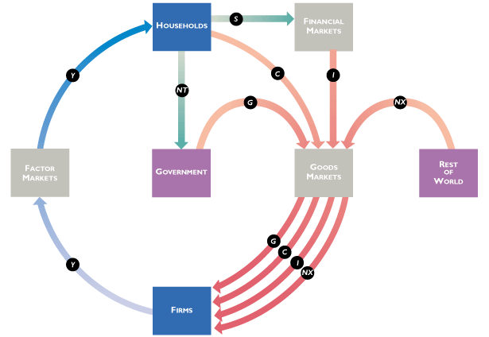
Fig. 22: Circular flow of income and expenditures

Figure 22 represents the circular flow of incomes and expenditures for a four-sector-model. These are Households-Firms-Government-Rest of the world. The model assumes that the households own the factors of production (i.e. land, labour, capital and entrepreneur) hence they render factor services to the firms.

First, the households earn income from rendering factor services to the firms. The households in turn save part of the income at the financial markets or spend in on consumption of goods and services. If the incomes are saved in the financial markets, firms (investors) go to borrow to produce goods and services. The firms in turn use the incomes they have received to purchase factors of production in the factor market from the households again and the cycle continues again.

Another flow of incomes and expenditures that we can identify from the figure is that, households pay tax to the government which is a source of government income. The government in turn uses the taxes to purchase goods and services in the goods market and thus gives income to the firms. The firms in turn use the income received from the government to purchase factors of production from the households in the factor market hence the households receive incomes which they either save consume and the cycle begins again.

The rest of the world buys goods and services from the goods market which implies they inject money into the goods market. The money received by the firms from exports is used in the factor market to purchase factor services from the households. The income received by the households from rendering factor services are either saved or consumed and the cycle begins. These analyses from the circular flow of incomes imply that income must necessarily be equal to expenditure.

Furthermore, we need to note that the circular flow of income summarizes macroeconomics which deals with the study of the complex interactions among the various components of the economy. Thus, we have recognized that there exist interactions between the households, firms, government and even the rest of the world which is the whole idea involved in the study of macroeconomics.

9.3 Expenditure Approach
The expenditure approach sums all the expenses incurred by economic agents in a country within a year.
Steps for calculating national income using the expenditure approach
- Gross Domestic Product at market prices (GDPmp) = C + I + G + NX
C = Total Consumption Expenditure e.g. education, housing etc.
I ₌ Total Gross Investment Expenditure of the firm e.g. purchase of capital equipment (business fixed investments), stock changes (inventory changes etc.).
G =Total Government Expenditures e.g. Construction of roads, payments of wages and salaries.
NX = Net Export: Exports (X) – Imports (M) expenditures

- Gross National Product at market prices (GNPmp) = GDPmp + or mimus P
Where; P is the Net Factor Income from Abroad

- Net National Product at market prices (NNPmp) = GNPmp – d , where d is depreciation/
Wear and tear/capital consumption allowance
But depreciation = Gross Domestic Investment – Net Domestic Investment

- National income (NY) = NNPmp- Indirect Taxes + Subsidies

- Disposable income Y^{d} = Personal Income – Income Tax
But, Personal Income = NY- retained profit – social security contribution – corporate income tax + government transfer payments to households + dividends + private remittances to households.

Per capita income 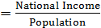

9.4 Income Approach
The income approach measures national income by summing all the earnings that accrue to the various factors of production in a country within a year. Unlike the expenditure approach, the income approach is always a net measure.

Table 8.1: Factors of Production and their reward
Factors of production | Reward/Earning
Land | Rent
Labour | Wages/Salaries
Entrepreneur | Profit
Capital | Interest

Thus, using the income approach, GDP = Profit+ Rent + Wages/Salaries + Interest

9.5 Uses of National Income Statistics
1. It is used to measure the welfare of citizens within a particular country: To do this comparison, a base year is chosen where prices have been relatively stable. Example, the national income for Ghana is represented as follows:

Table 8.1: National Income of Ghana
Year | National income ( US $)
2006 | 390
2010 | 650
2012 | 1500

From table 8.1, it is obvious that the national income for Ghana in 2012 was $1500 which is more than twice that of the value recorded in 2010 which was $ 650. We can quickly conclude that the economy of Ghana performed better in 2012 as compared to 2010.

2. It is used to compare the welfare of citizens between two or more countries: National income is a reasonable measure of economic performance between two or more countries. This is achieved by using the purchasing power parity. Purchasing Power Parity is the conversion of the currency of two or more countries into a common unit so that a unit of the one currency can buy the same amount of good in any of the countries. Example the national income figures for Ghana and Nigeria are as follows:

Table 8.2: National Income for Ghana and Nigeria
 |  | National Income (US $)
Country | Year | 2010 | 2012
Country | Ghana | 650 | 1500
Country | Nigeria | 700 | 2000

From table 8.2, we notice that the national income for Nigeria in 2010 was $700 which is relatively higher than that of Ghana in the same year ($ 650). Therefore, we can conclude that Nigerian economy performed relatively better than the Ghanaian economy in 2010 and even in 2012 as well. However, in terms of welfare this may not be valid since welfare is a broader concept than a mere economic performance.

It is used to track the course of business cycle: Fluctuations in the pace of expansion of real GDP is called the business cycle. The business cycle is a periodic irregular up-and down movement of total production and other measure of economic activity. The four stages of a business cycle are; expansion, peak, recession, and trough. Expansion occurs when real GDP grows along potential GDP and recession occurs when there is a decline in Real GDP.

9.6 Limitations of using National Income as a measure of welfare across countries
Though national income is a good indicator of economic performance, it is a weak measure of welfare both within and across countries. The general reason is that, welfare is a broad concept and there are several components of welfare which are ignored in national income statistics as follows:
It does not account for leisure: Leisure is an important measure of welfare however; the national income statistics does not give indication of the amount of leisure enjoyed by the citizens of a country. For instance, the national income for Ghana may be higher than that of Nigeria for a given year but in terms of leisure Nigeria may have high amount of leisure than Ghana. Therefore, higher national income does not necessarily imply a better welfare.
It does not take into non-market activities: Unfortunately, the national income is obtained only for products which are marketed however, home production such as activities of a house wife or a farmer who produces to feed his family are not captured which are also measures of welfare at the household level.
It does not account for the underground economy: Unfortunately, national income data does not reflect the size of the underground economy. Thus, illegal activities such as “galamsey” and smuggling of products are not taken into account. It is possible that a country with a high national income will have a bigger size of the underground economy as compared to the one with a lower national income.
It does not account for environmental quality: Environmental quality in terms of the extent of pollution generated cannot be ignored from the discussion of welfare measures. However, national income statistics is silent on the level of pollution generated in a country. It is likely that a country with low national income will have a lower level of pollution than a country with high national income.
It is silent on health and life expectancy: Health and life expectancy are very paramount to welfare. Life expectancy refers to the average number of years that people can live however; the national income statistics is silent on the health and life expectancy of the people in a country.

Concluding Notes on National income (GDP) calculation/accounting

In the computation of GDP, the following need to be well noted
- C, I, G, and NX (net exports): If a person spends money to renovate a hotel to increase occupancy rates, the spending represents private investment, but if he buys shares in a consortium to execute the renovation, it is saving. The former is included when measuring GDP (in I), the latter is not. However, when the consortium conducted its own expenditure on renovation, that expenditure would be included in GDP.
- If a hotel is a private home, spending for renovation would be measured as consumption, but if a government agency converts the hotel into an office for civil servants, the spending would be included in the public sector spending, or G.
- If the renovation involves the purchase of a chandelier from abroad, that spending would be counted as C, G, or I (depending on whether a private individual, the government, or a business is doing the renovation), but then counted again as an import and subtracted from the GDP so that GDP counts only goods produced within the country.
- If a domestic producer is paid to make the chandelier for a foreign hotel, the payment would not be counted as C, G, or I, but would be counted as an export.

ASSIGNMENT

Question 1:
The following statistics were supposedly provided by Ghana Statistical Services for 1990: All figures are in millions of cedis.

Government Transfer Payments………………………………………….50
Consumption Expenditures……………………………………………...540
Indirect Taxes…………………………………………………………….70
Direct Income Tax………………………………………………………..80
Corporate Income Tax…………………………………………………...40
Government Expenditures………………………………………………280
Gross Domestic Investment…………………………………………….150
Retained Profit…………………………………………………………...60
Dividend…………………………………………………………………20
Net Domestic Investment……………………………………………….100
Net Export……………………………………………………………….-60
Corporate Profit………………………………………………………....120
Social Security Contribution…………………………………………….30
Subsidy…………………………………………………………………..20
Net Factor Income from Abroad………………………………………..-30

Compute the following:
- Gross Domestic Product (GDP)
- Gross National Product (GNP)
- (Net National Product (NNP),
- National Income (NY)
- Disposable Income (Y^{d} )
Question 2:
Table 8.3: Components of GDP in Ghana
Component | Amount (GH¢M) | Component | Amount (GH¢M)
Consumers’ expenditure | 367853 | Capital consumption (Depreciation) | 63968
Subsidies | 5878 | Stock changes | -5303
Rent | 44092 | Fixed investments | 95442
Net factor Income from abroad | 328 | Exports | 135115
Government Exp. | 121899 | Wages | 387315
Taxes on Exp. | 83023 | Other factor incomes | 1665
Profits | 63912 | Imports | 140415

Table 8.4 lists a number of components of a Gross Domestic Product (GDP) from both income and expenditure sides of an account assumed to be coming from Ghana in a particular year. All quantities are measured in GH¢’ million at current prices. Using the expenditure side of the account, calculate the following:
- Gross Domestic Product (GDP) at market prices.
- Gross National Product (GDP) at market prices.
- Gross Domestic Product at factor cost.
- National Income.
- Calculate Gross Domestic Product at factor cost from the income side of the accounts.
- Can you explain why your answers in (c) and (e) are not identical?
- Explain three limitations of using GDP obtain in the year as a measure of welfare.

ANSWER TIPS

Question 1
- Gross Domestic Product at market prices (GDPmp) = C + I + G + X-M

But, I = Fixed investment + stock changes = 63968 + (-5303) = GH¢58665 million.

GDPmp = 367853 + 58665 + 121899 + (135115 + 140415) = GH¢ 57459 million.

- Gross National Product at market prices (GNPmp) = GDPmp + Net Factor Income from Abroad = 574591 + 328 = GH¢ 574919 million.
- GDP at factor cost = GDPmp – taxes on expenditures + subsidies = 574591 – 83023 + 5878 = GH¢ 497446 million.

- National income (NY) = GDP at factor cost – Capital consumption = 49744 – 63968 = GH¢ 410623 million.

- From the income side, GDP at factor cost = Rent + Profits + Wages and Other factor incomes = 44092 + 63912 + 387315 + 1665 = GH¢ 496984 million.

- Theoretically, the expenditure approach (c) and the income approach (e) are supposed to yield the same result. However, the answers in (c) and (e) are not identical due to statistical discrepancies’ such as human and computational errors.

- Limitations of using GDP as a measure of welfare are as follows:
- It does not account for leisure which is also an important measure of welfare.
- It does not take into consideration home production e.g. activities of a house wife or a farmer who produces to feed his family
- It does not account for the underground economy e.g. Smuggling.
- It does not account for environmental quality e.g. pollution
- It is silent on life on health and expectancy which are also important components of welfare.

